WEEK-12

1 DEPLOYMENT OF INDEX.HTML USING EC2 INSTANCE in AWS

**Step 1: Login to AWS /canvas account**

* Go to course invitation mail and click on start
* Opens the aws academy, select the student login and enter the email and password details
* Click on Modules
* Scroll down and select Lunch AWS Academy Lab-
* Click on start Lab and wait AWS becomes from red to green AWS

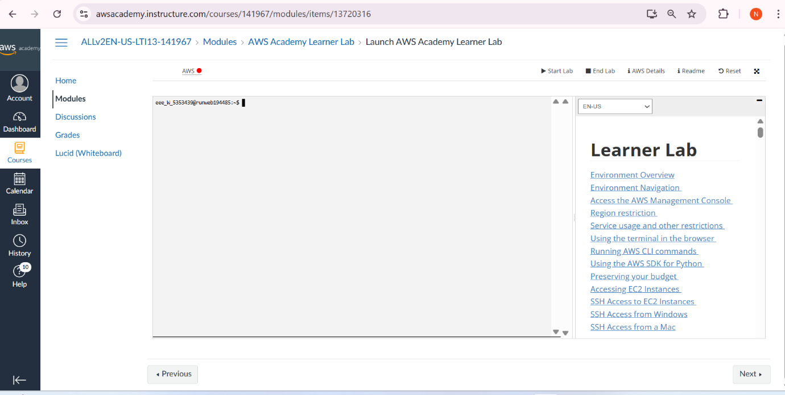

**Click on AWS**

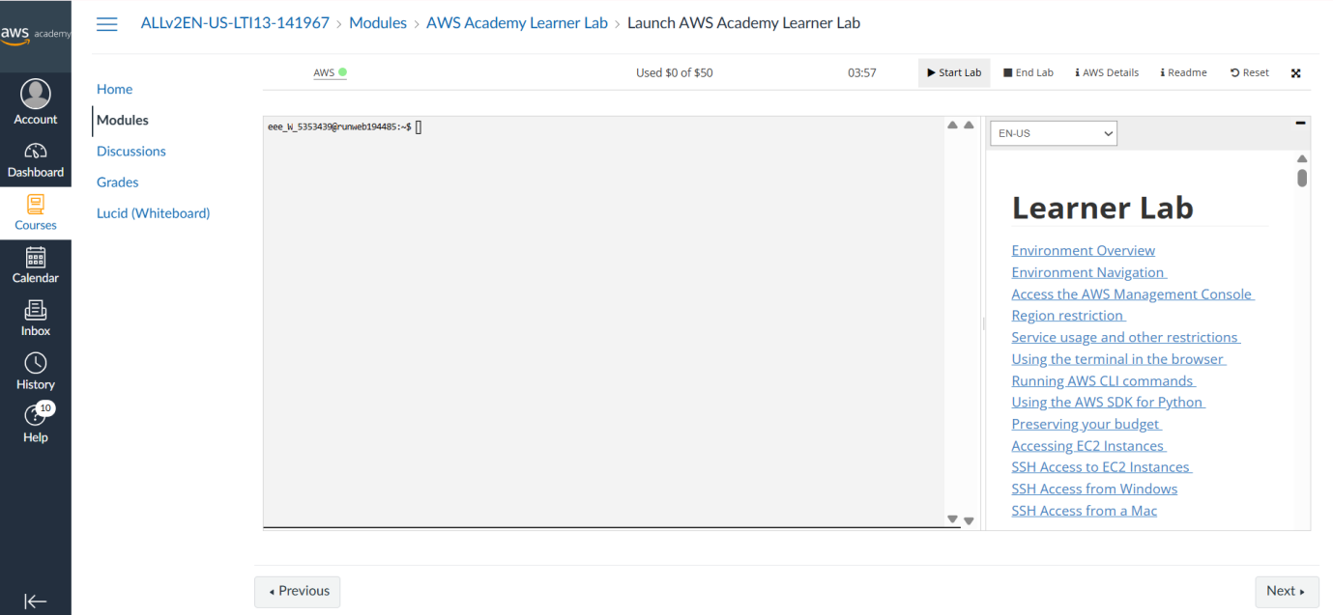

**Step 2:** **Click on EC2 to create instance**

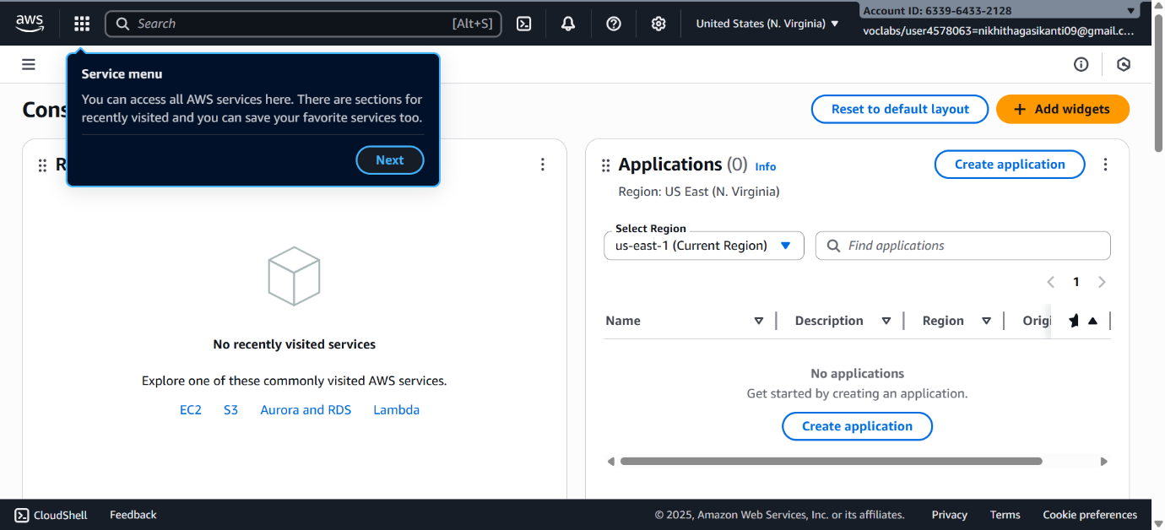

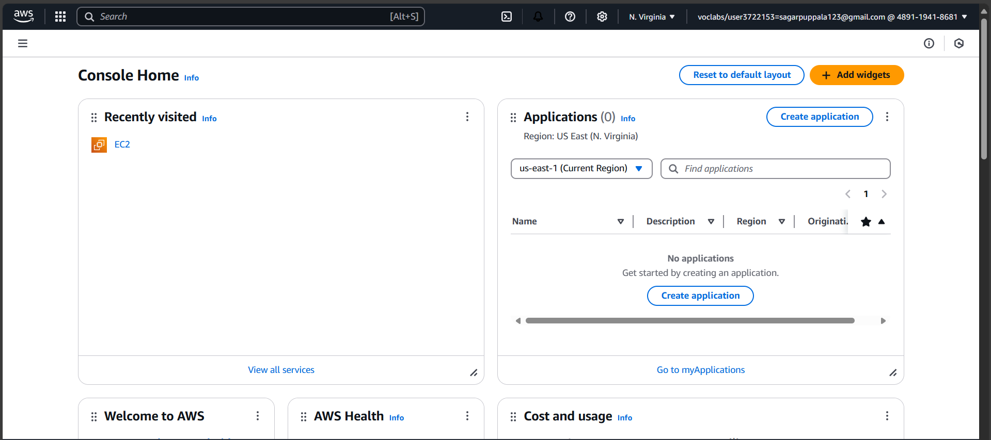

**Click on Launch Instance**

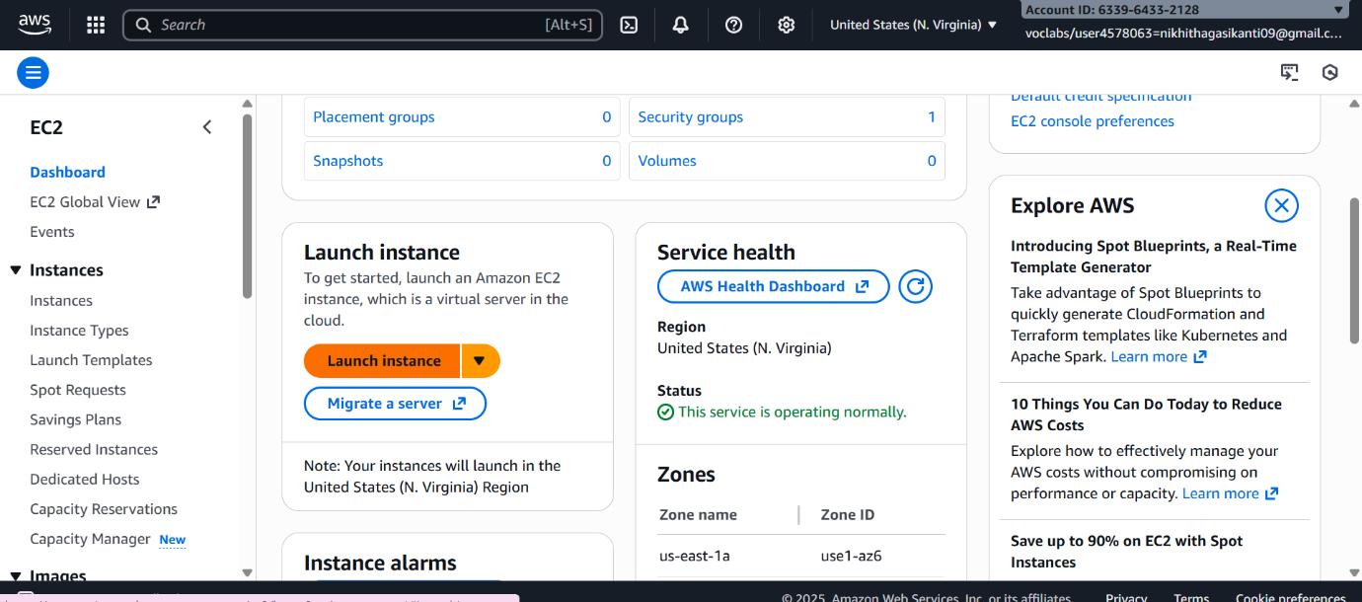

Stage 1 --Name (Giving name to the machine) ubuntu

Stage 2 -- Select AMI ( Note: Select free tier eligible ) ubuntu server

**Give name and select ubuntu** under application

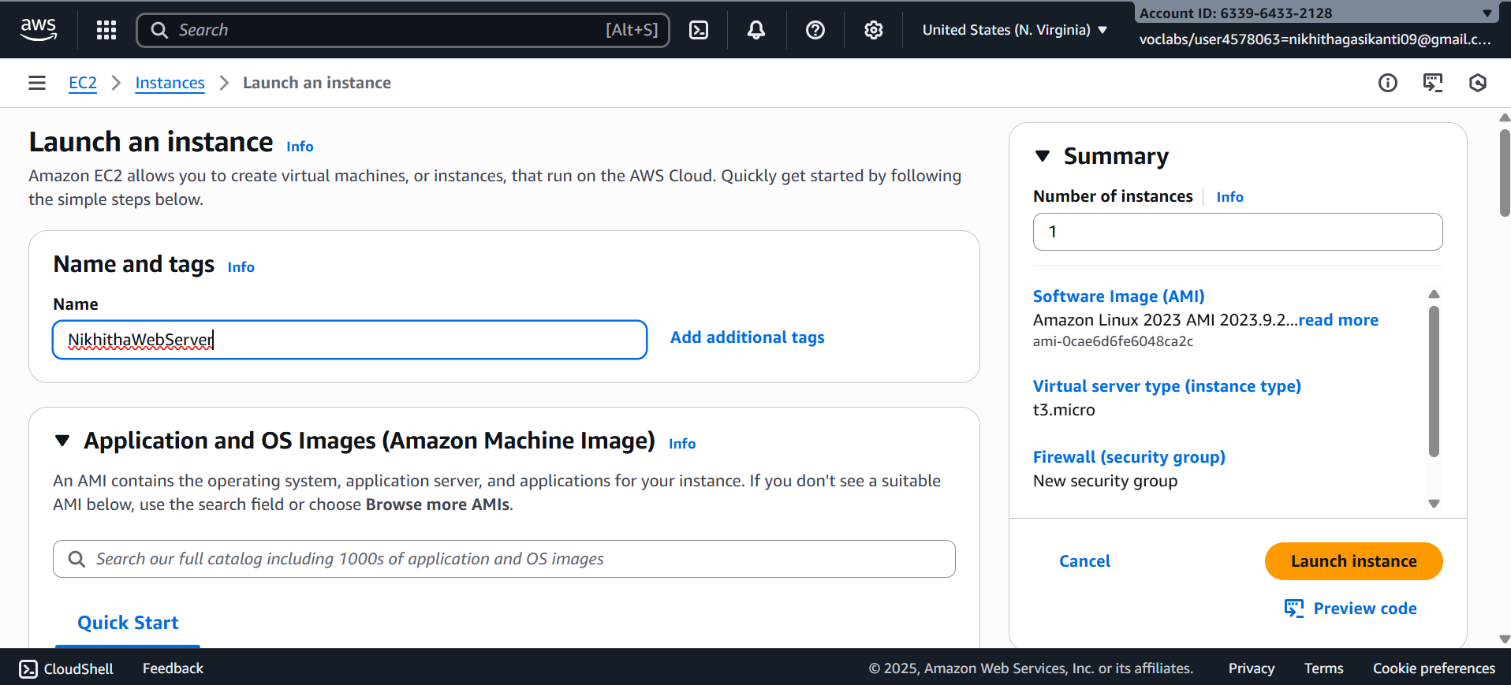

**Select this free tier option of Ubuntu from here**

Stage 3 -- Architecture as 64-bit

Make sure AMI and Architecture are there as shown

Stage 4 -- **Instance type** ---- t2.micro(default 1 CPU,1 GB RAM)

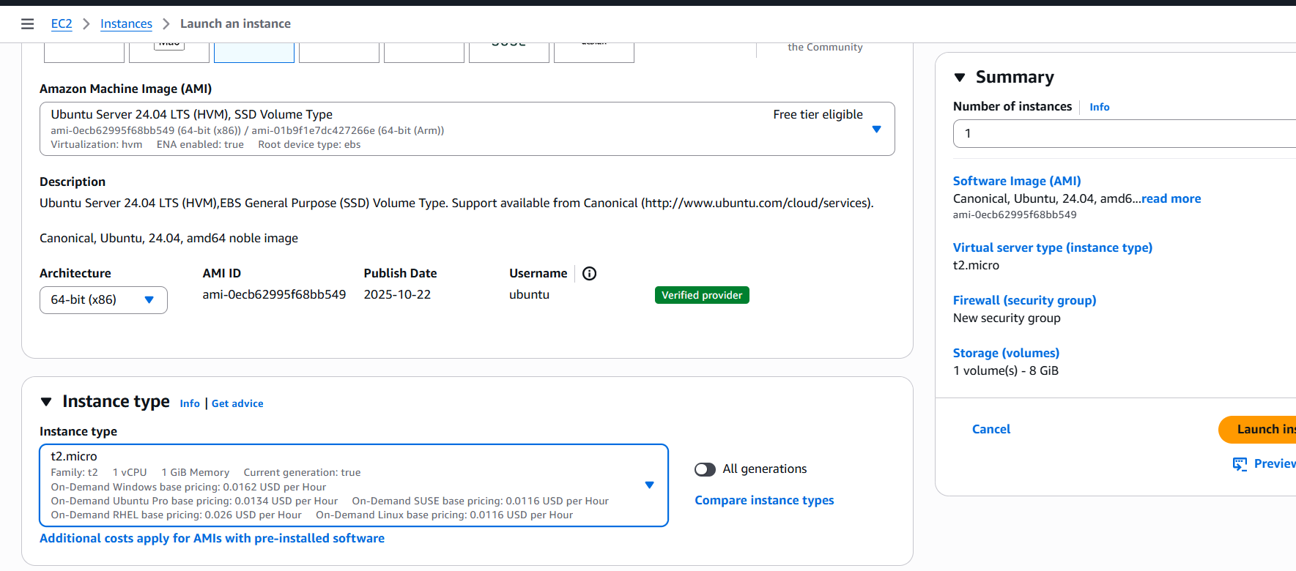

Stage 5 -- Create a new keypair---a keypair will downloaded with extension .pem

Store key in folder AWS

**First Click on create-new key pair**

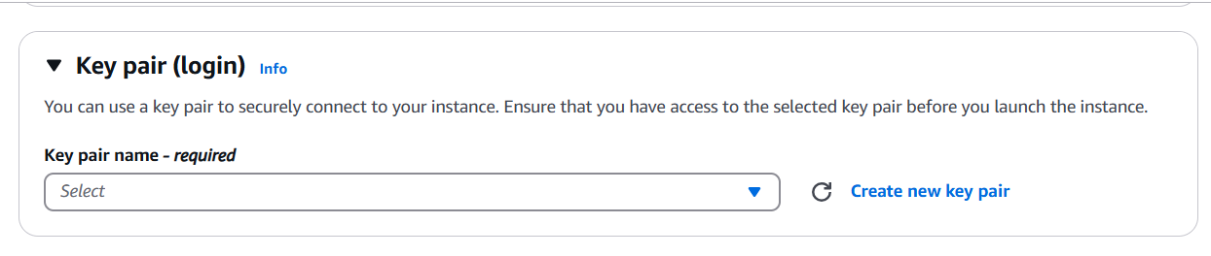

Give KeyPair name and click on create key pair

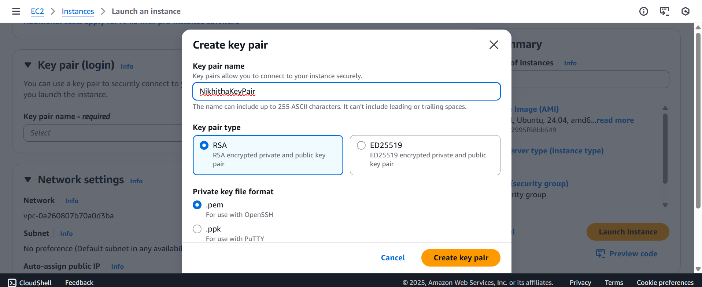

Save the .pem file in folder AWS on desktop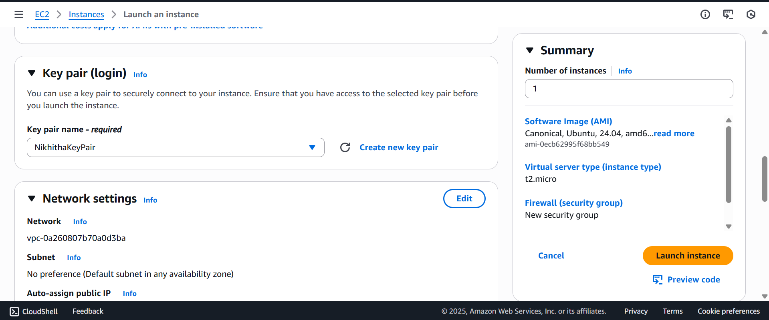

Stage 6 -- Network Setting ----Create Security group -- ( It deals with ports )

(Note for understanding We have 0 to 65535 ports. Every port is dedicated to special purpose)

**HERE select https and http** (which allow to load your web pages while execution)

In network setting check all the checkboxes

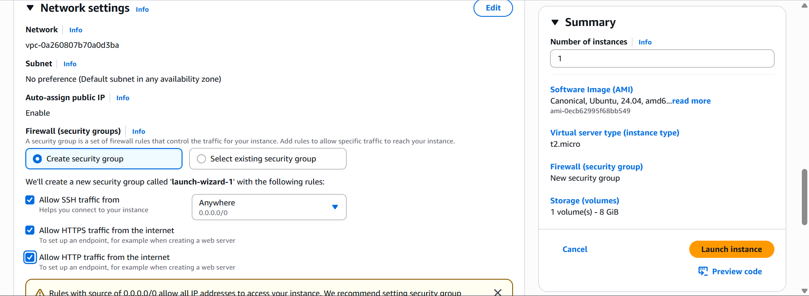

Stage 7 -- Storage - 8GB ( Observation - we have root - it is same as C Drive) it default 8 GB

Stage 8 --- click on launch instance

Now click on the instances

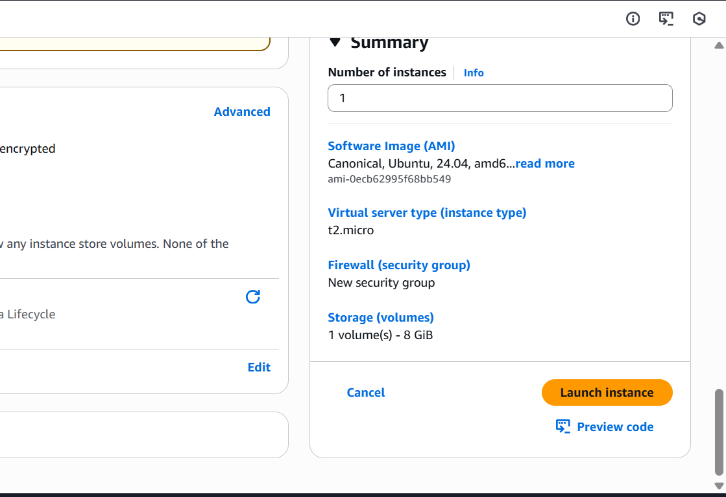Wait for the Success message to apper in green color

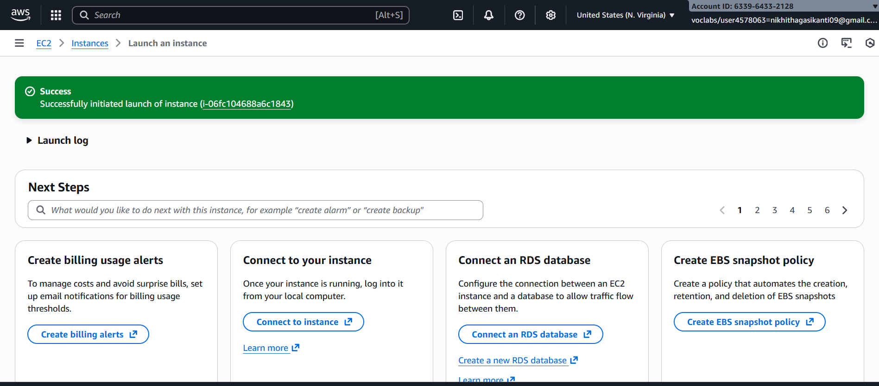

You can see MyExampleWebServer is Running and wait for it to initialize

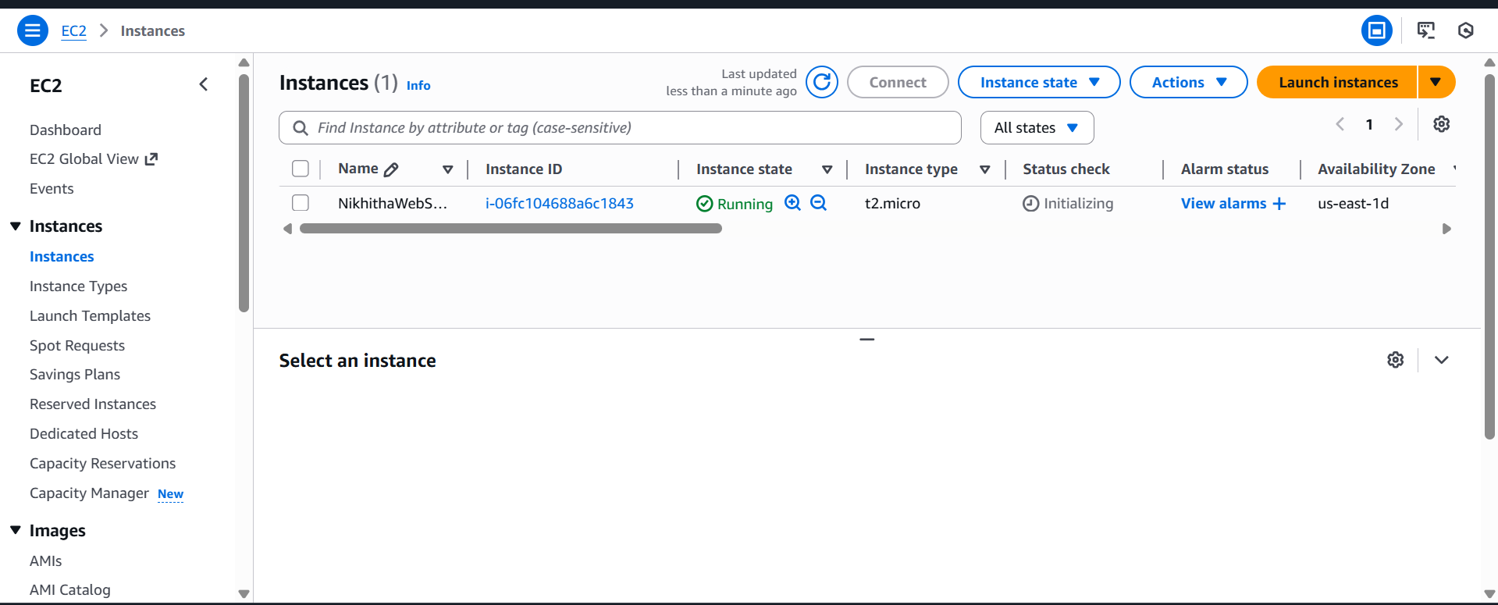

You have to get 2 tests passes.

Important:---- Now check the box and click on connect.

**Do this step:---once it is created select that instance**

**(Tick in checkbox) and click on connect**

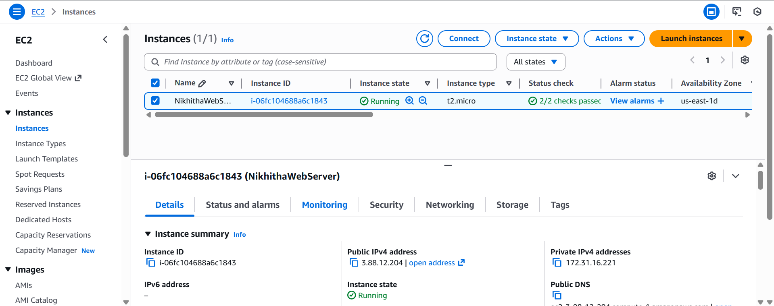

Thus your EC2 instance is running on server.

Step 4: Now you can connect local system to server (EC2 instance) using secure shell SSH.

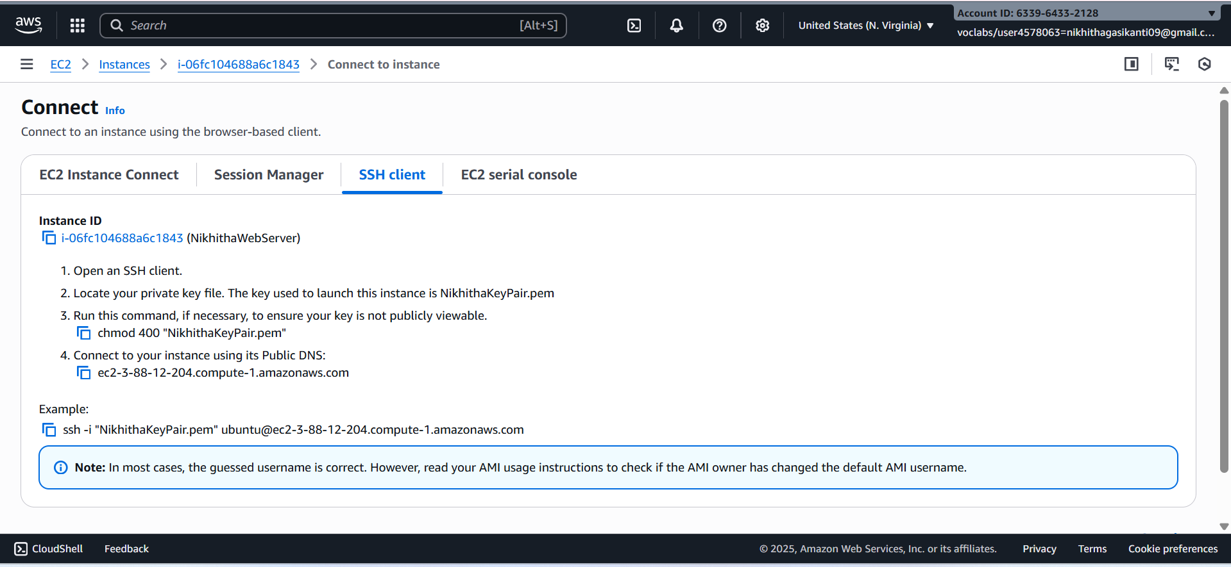

For this, **Here copy the ssh – i command from SSH client connect tab and paste later**

Next We can use powershell /gitbash /webconsole **in administrative mode**, to connect to ubuntu machine.

Step a: Copy the path of .pem file that you saved earlier in folder AWS eg. as here C:\Users\RAMM\Desktop\AWS

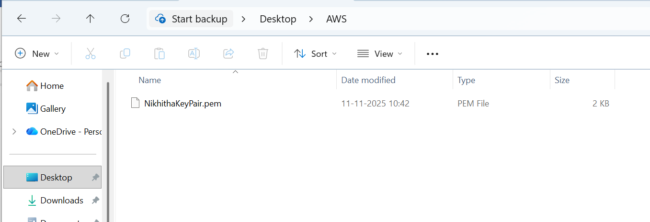

Step b: Open Powershell in administrative mode and navigate to that path.

Type: cd < path>

eg. here specify your .pem path

Step c: Go to SSh and copy the command ssh which is present at the below



Note: To connect to above terminals we need to go into the path of the keypair.and

paste the ssh -i command from the aws console

**ssh -i "NikhithaKeyPair.pem" ubuntu@ec2-3-88-12-204.compute-1.amazonaws.com**

Step d: **Run the pasted** ssh -i **command in the terminal**

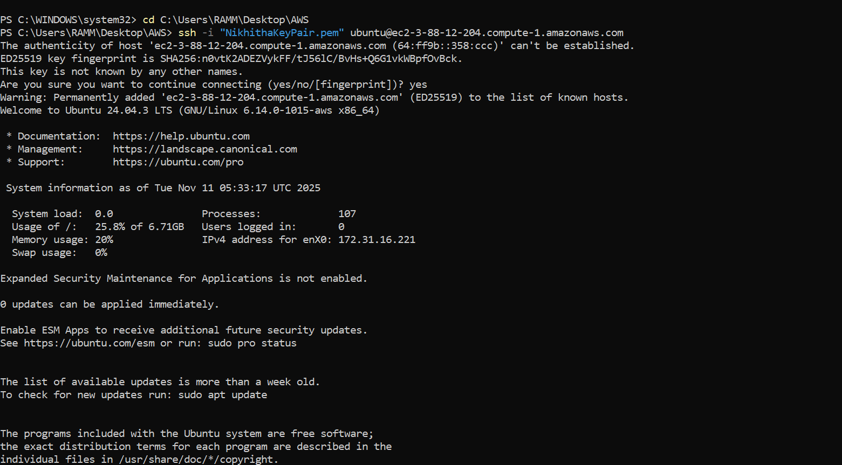

Step 5: Run the following commands to install s/w

1. Update all softwares in Ubuntu by command

**sudo apt update**

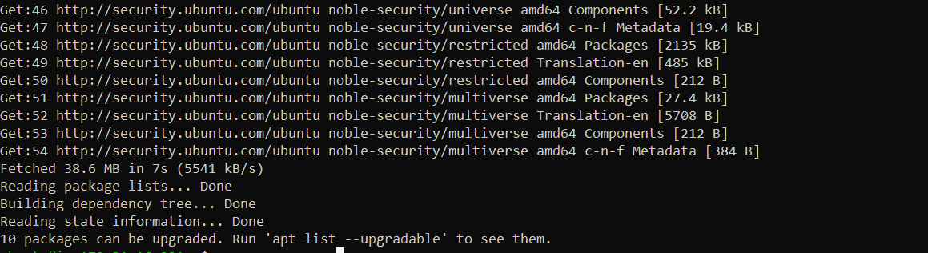

1. Install docker by command

**sudo apt-get install docker.io**

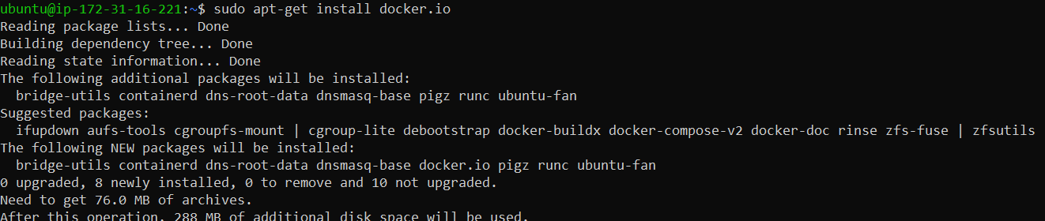

1. Install git by command

**sudo apt install git**

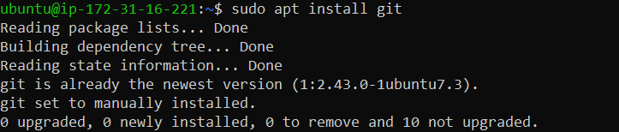

1. Install nano( text editor) by command

**Sudo apt install nano**

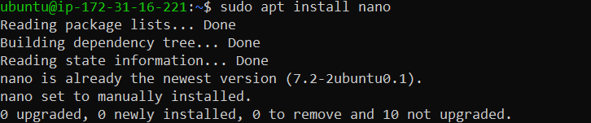

Step 6: Now we want to create an application, push it into git, create docker image of it and run it

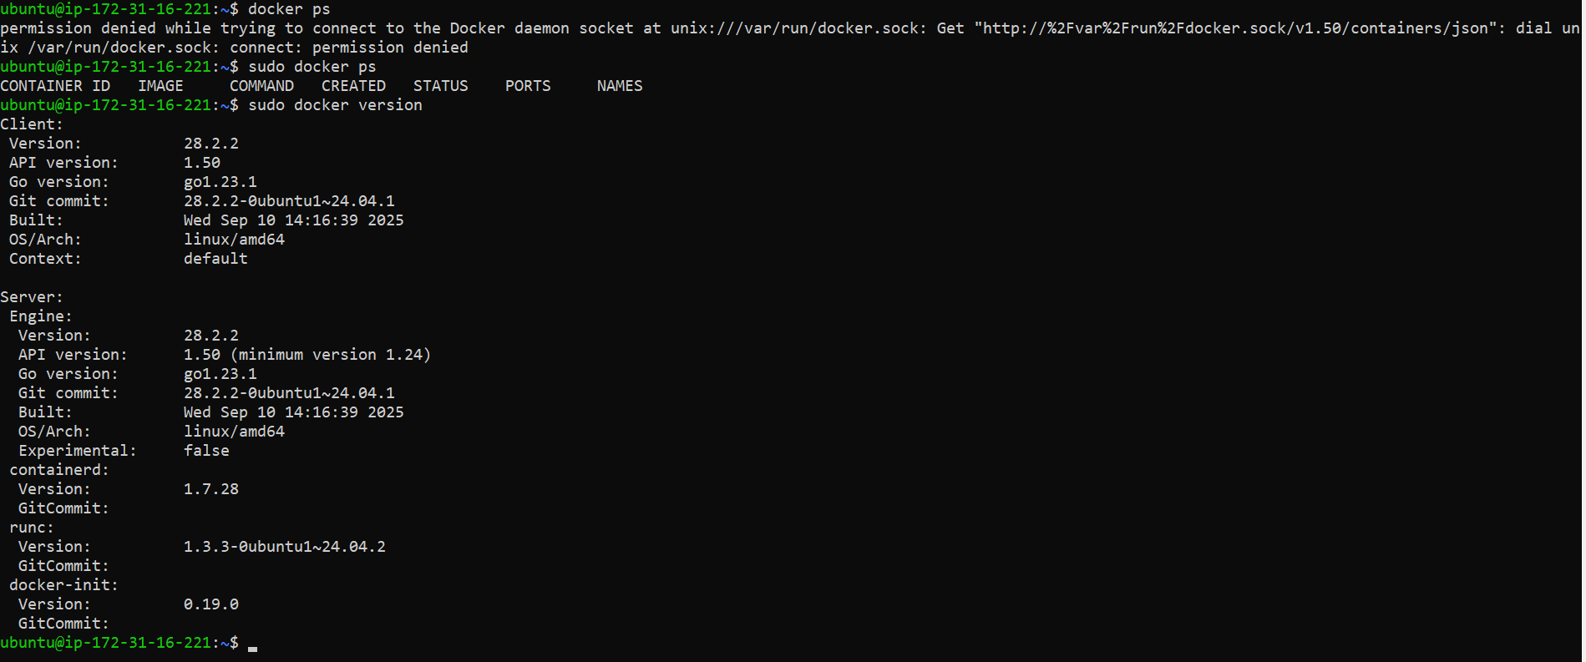

**Step a:** Create basic index.html file in folder Example and save it

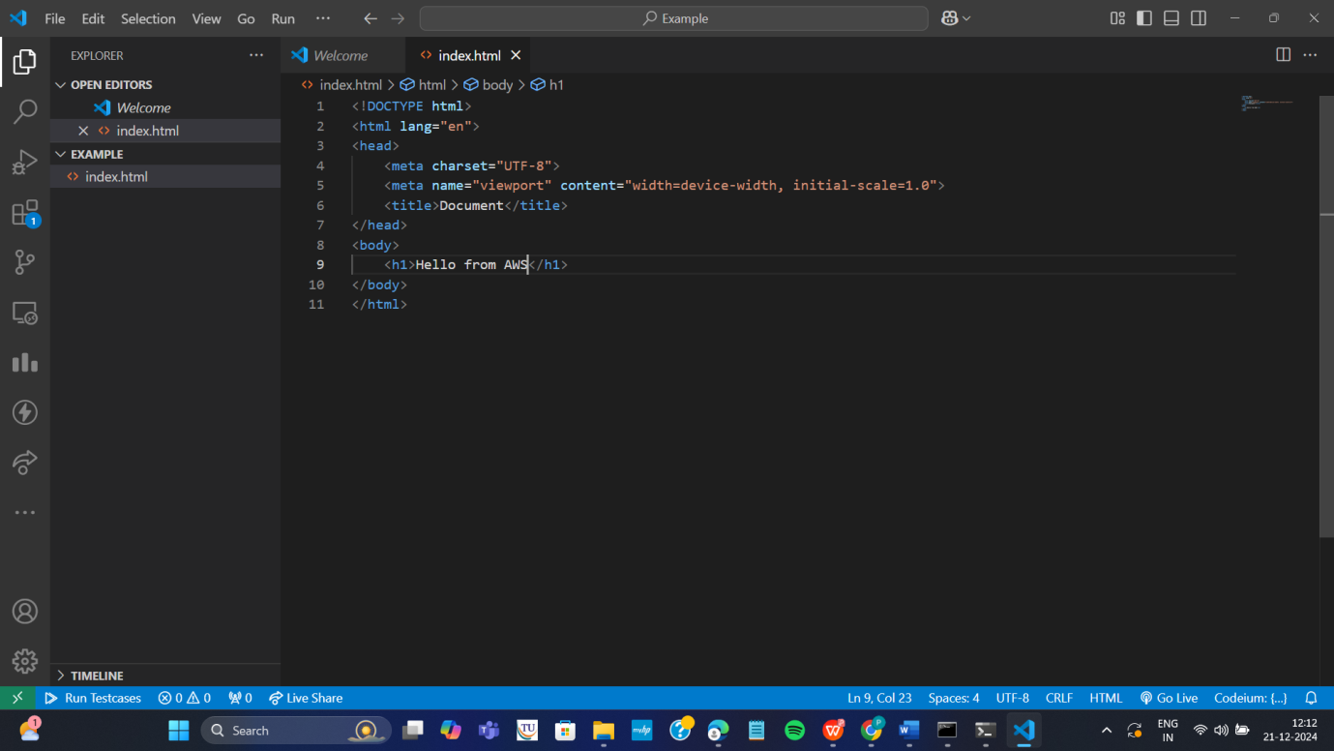

**Step b:** Open git Bash **in folder Example** by right clicking with mouse

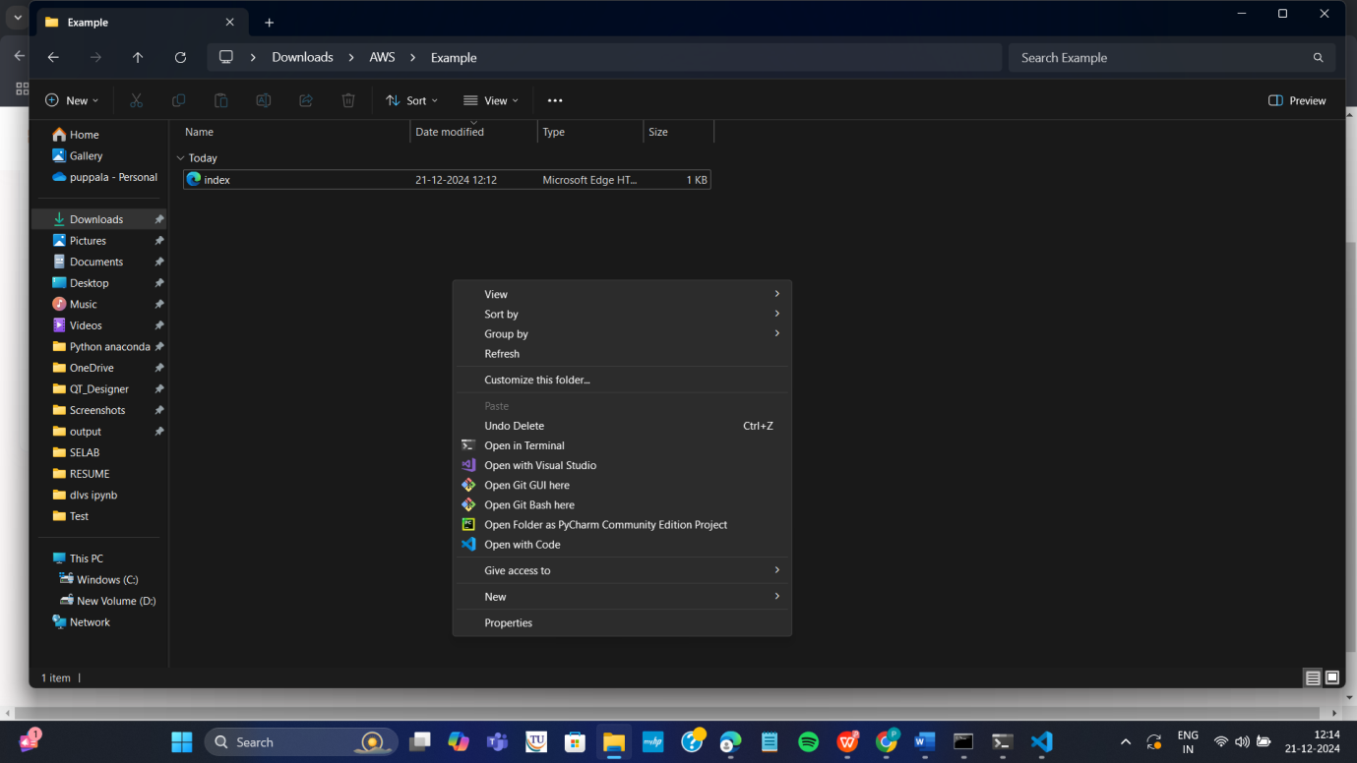

**Step c:** In git bash run the following commands

**git init**

**git add .**

**Git commit –m “first commit”**

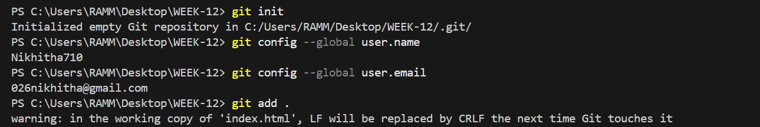

**Step d:** Create git repository (here with name AWS)

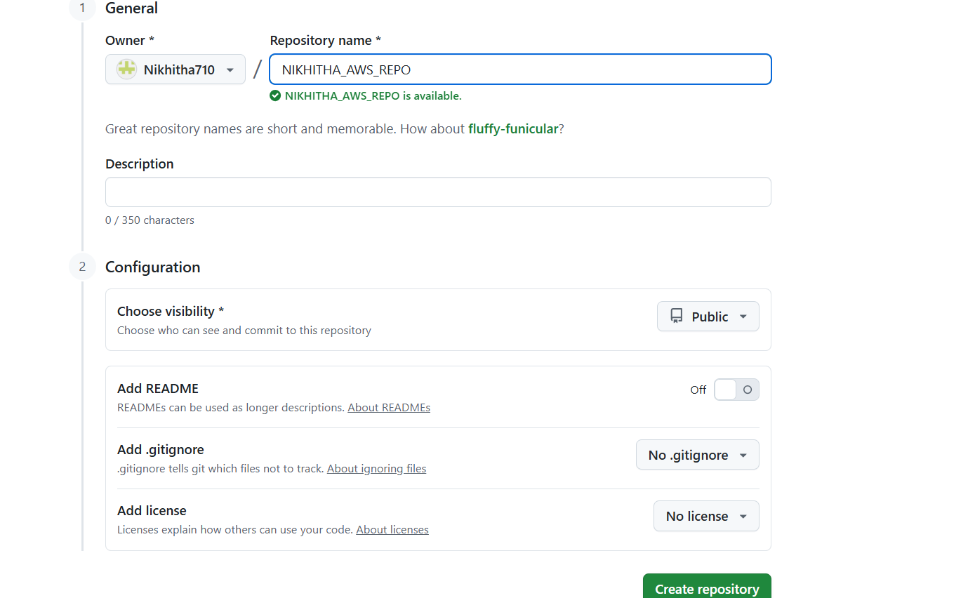

**Step e:** Copy command **one by one** from above repository and run as below

**git branch –M main**

**git remote add origin <https url>**

**git push –u origin main**

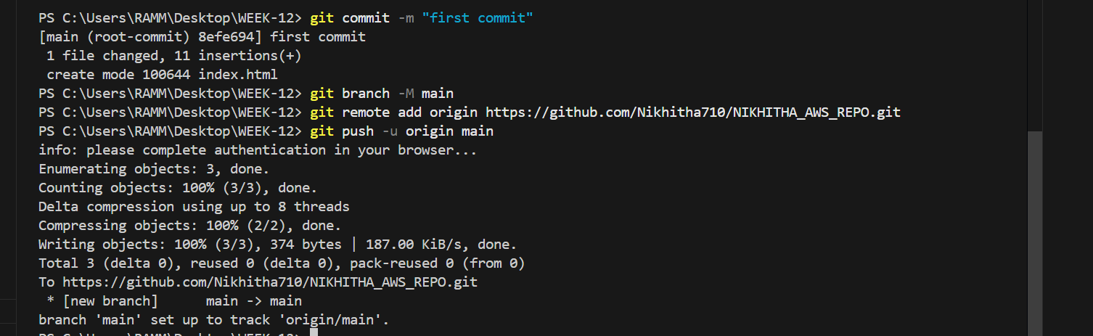

**Step f:** refresh repository and You can now see index.html in github

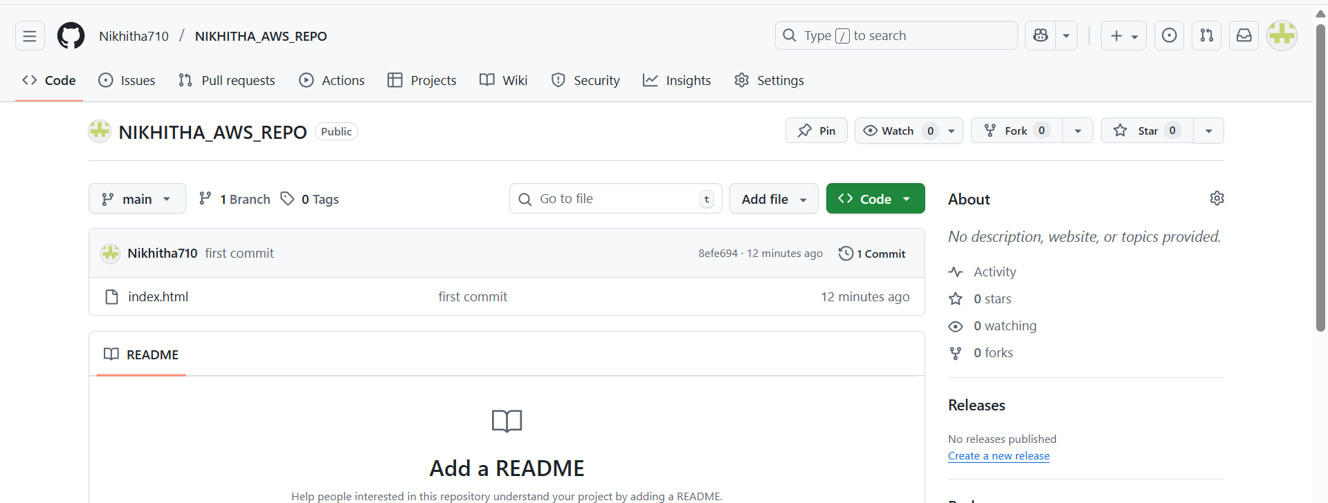

**Step g:** Copy http path

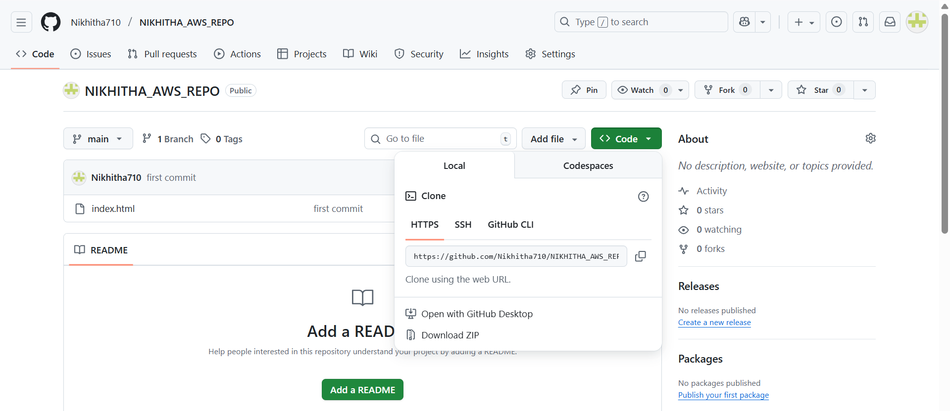

**Step h:** Clone the repository with copied http path by command **in command prompt git clone <copied http url>**

**Step i:** Navigate to the cloned folder. Type **cd AWS** as below, next **ls** to

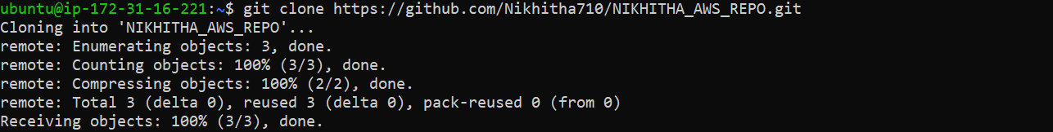

**Step j:** create Dockerfile in above command prompt in ububtu ie in power shell

**Nano Dockerfile**



**Step k:** Write the following data in Dockerfile and click ctrl+o Enter and then ctrl-x

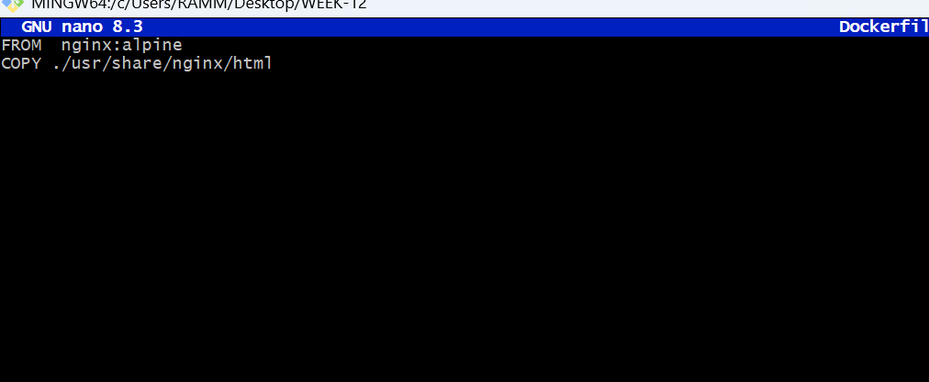

**Step L:** Build docker image by executing the following command

**sudo docker build –t mywebapp .**

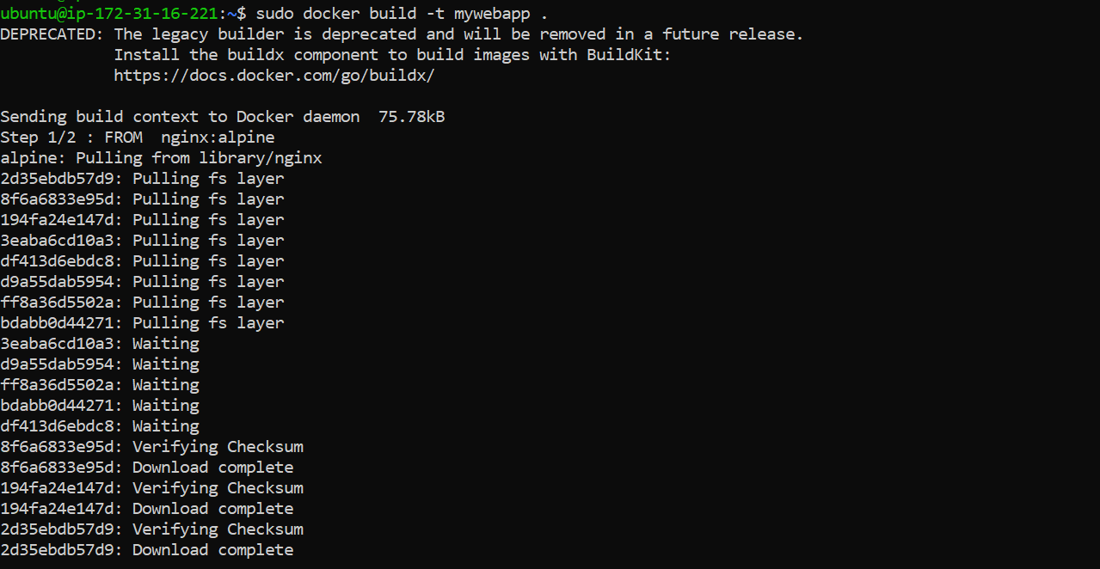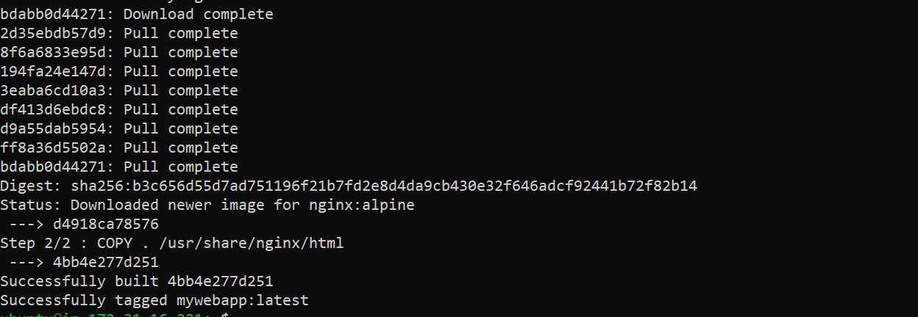

Thus image is created

**Step m:** run the image and map it to port 80

**sudo docker run –**d –p 80:80 mywebapp



**Step n:** Go to instances and click on instance here



**Step o:** Copy public ipv4 address

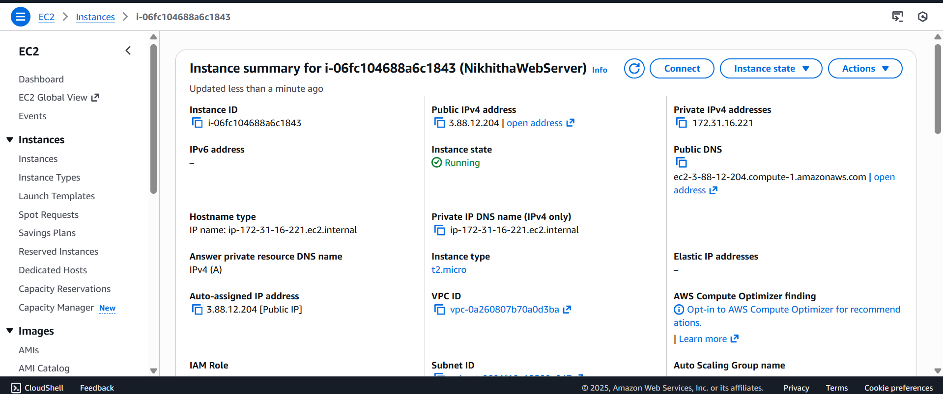

**Step p:** Paste it in the browser to get below output

**Note :** if https :__ won’t work then type just http:___

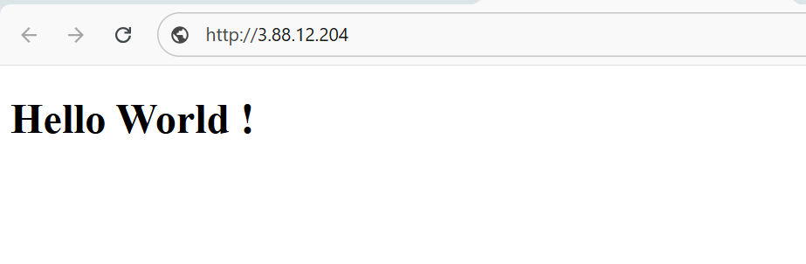

**Important do it without fail. Step Q:** stop container

Run the following command to stop the container

1. sudo docker ps
2. sudo docker stop <container-id>

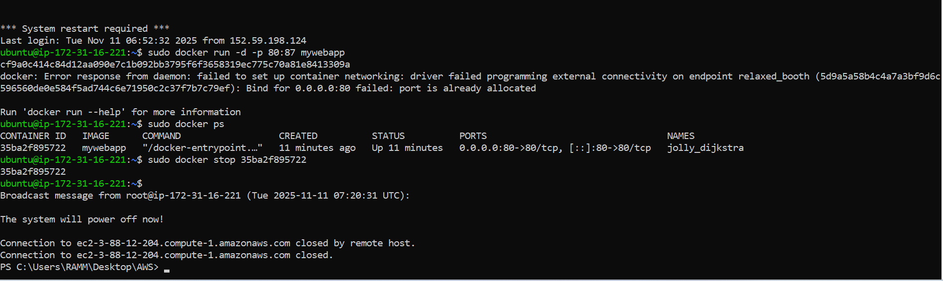

1. Go back to instances and click on option instance. Once load as below, then Click on Instance state and select terminate instances

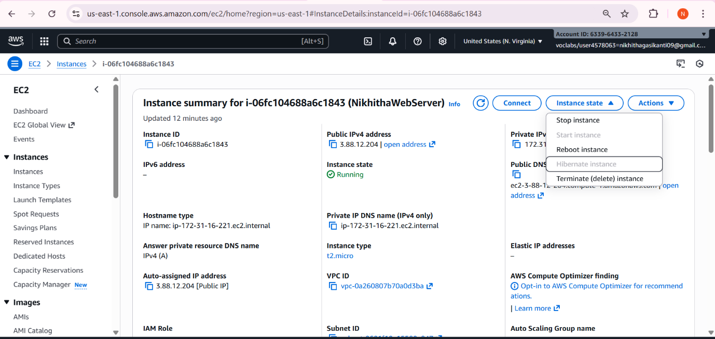

Click on Terminated (deleted)

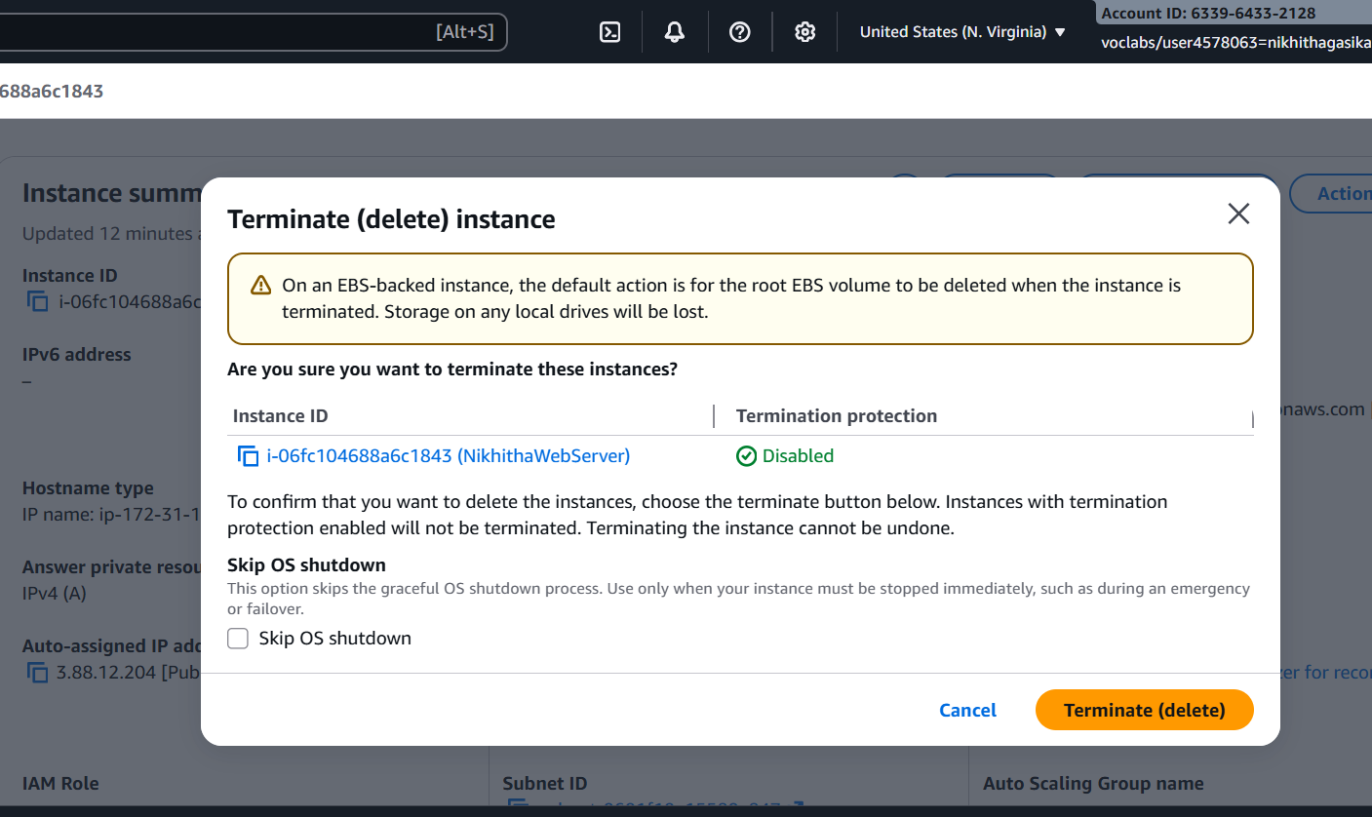

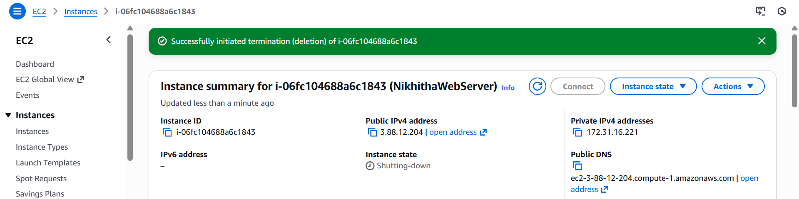

1. Now click on End lab

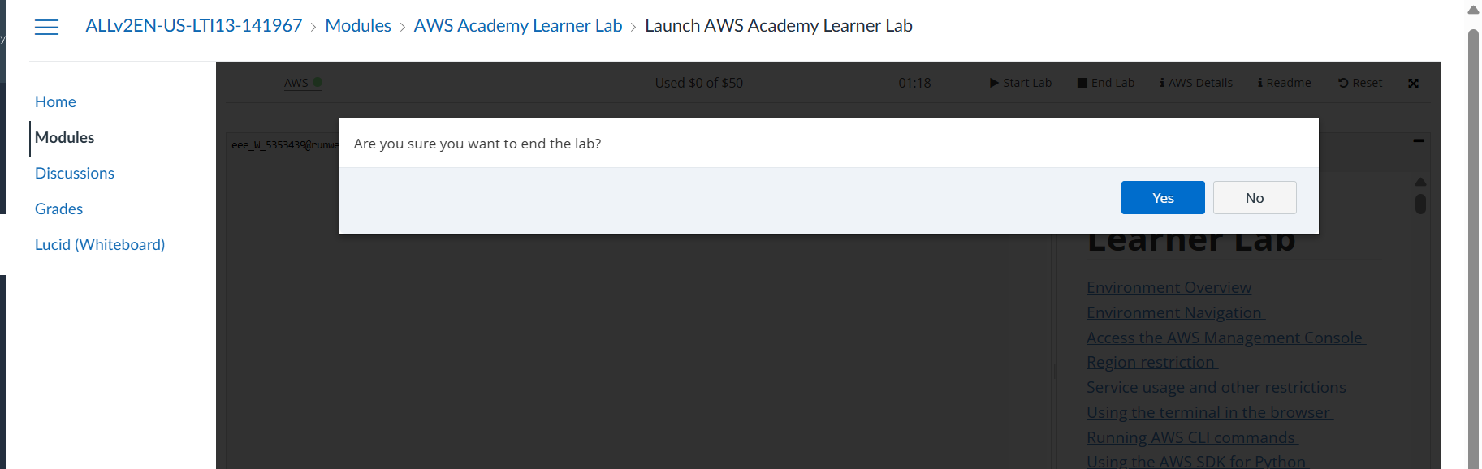

2 MAVEN WEB PROJECT DEPLOYMENT IN AWS

Click on start lab

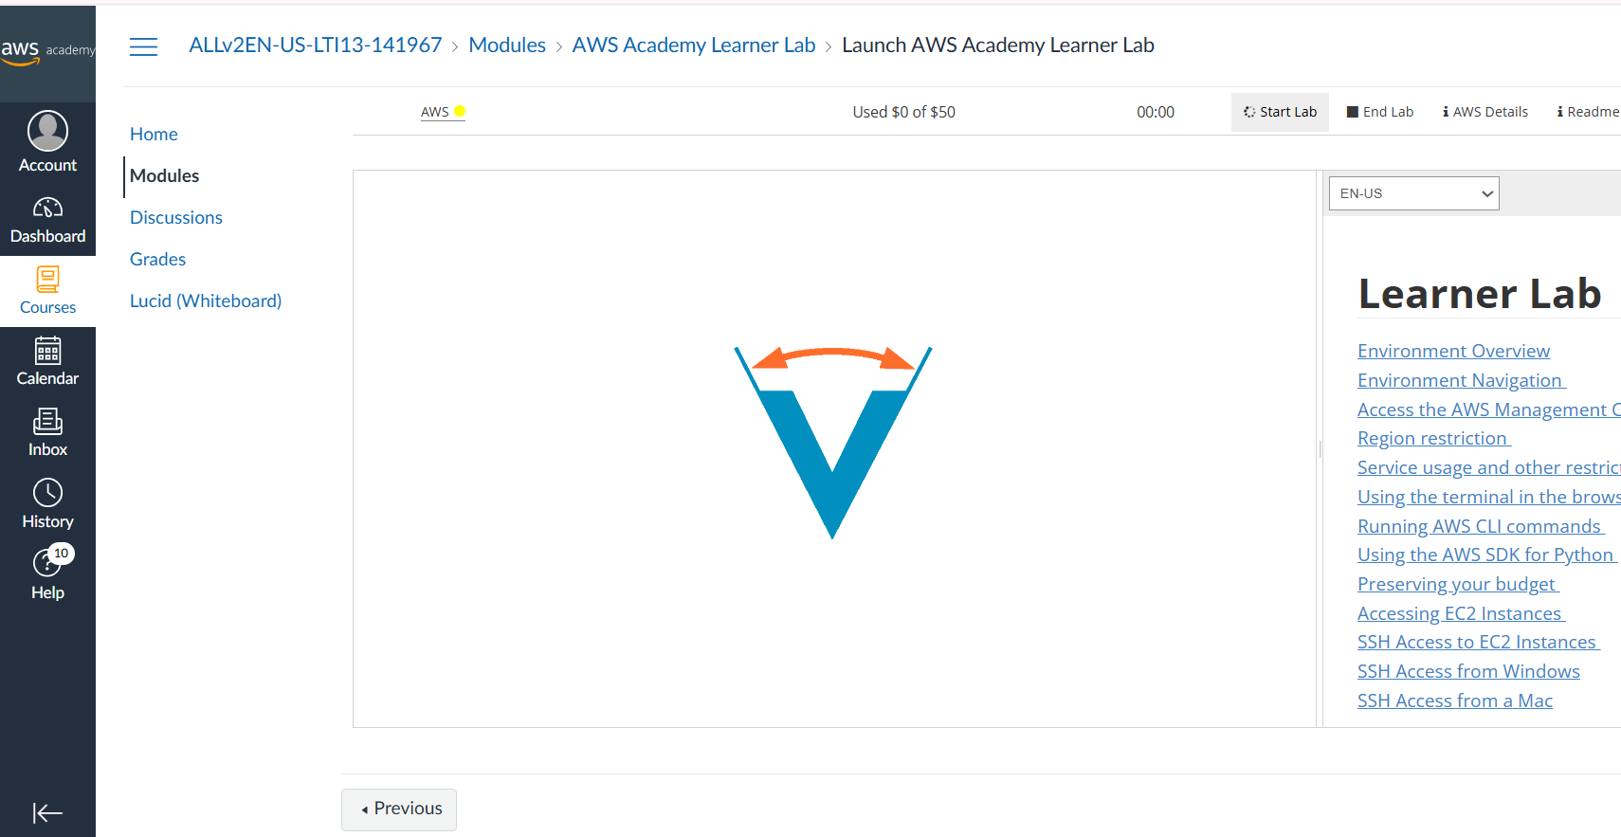

Click on AWS

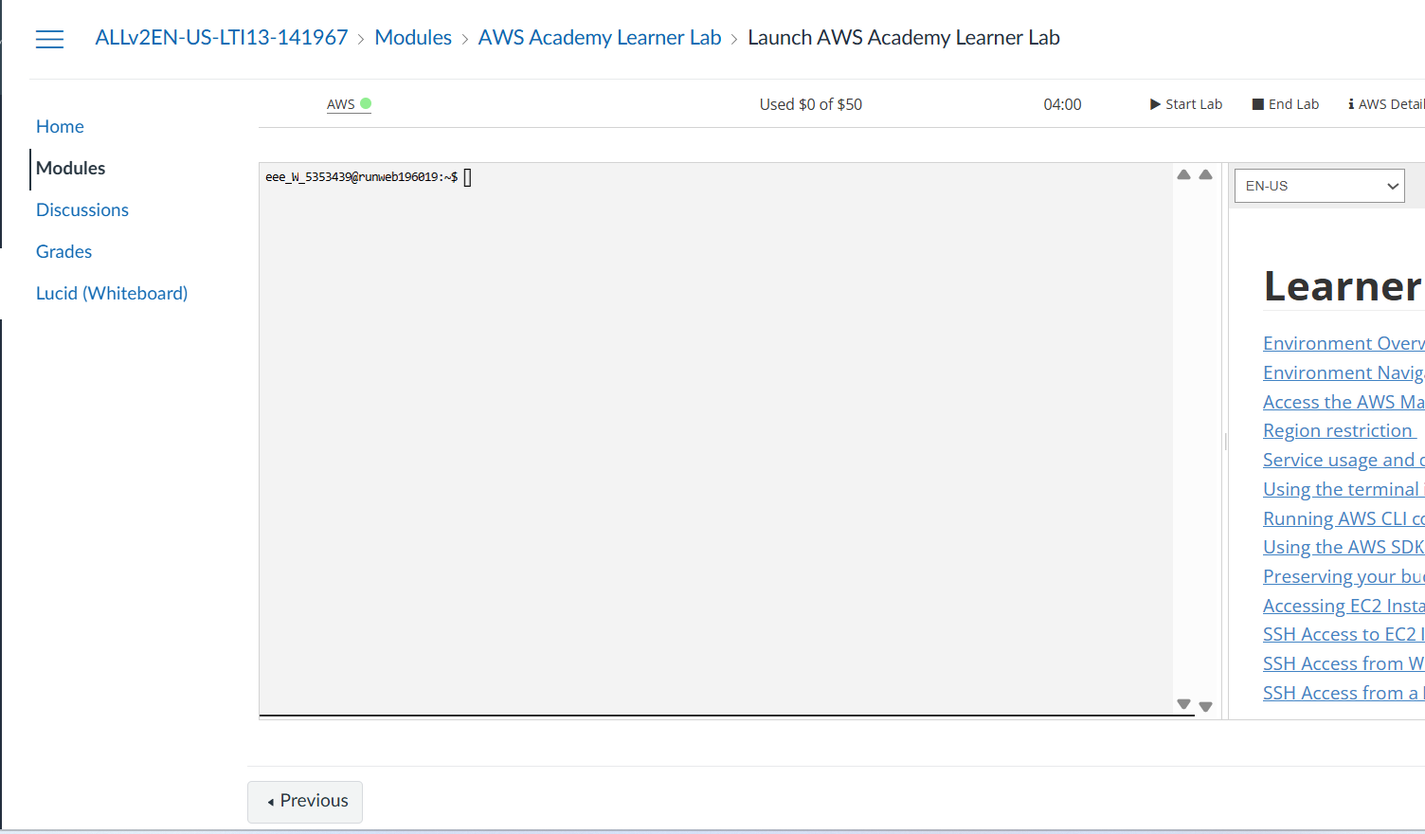

Click on EC2

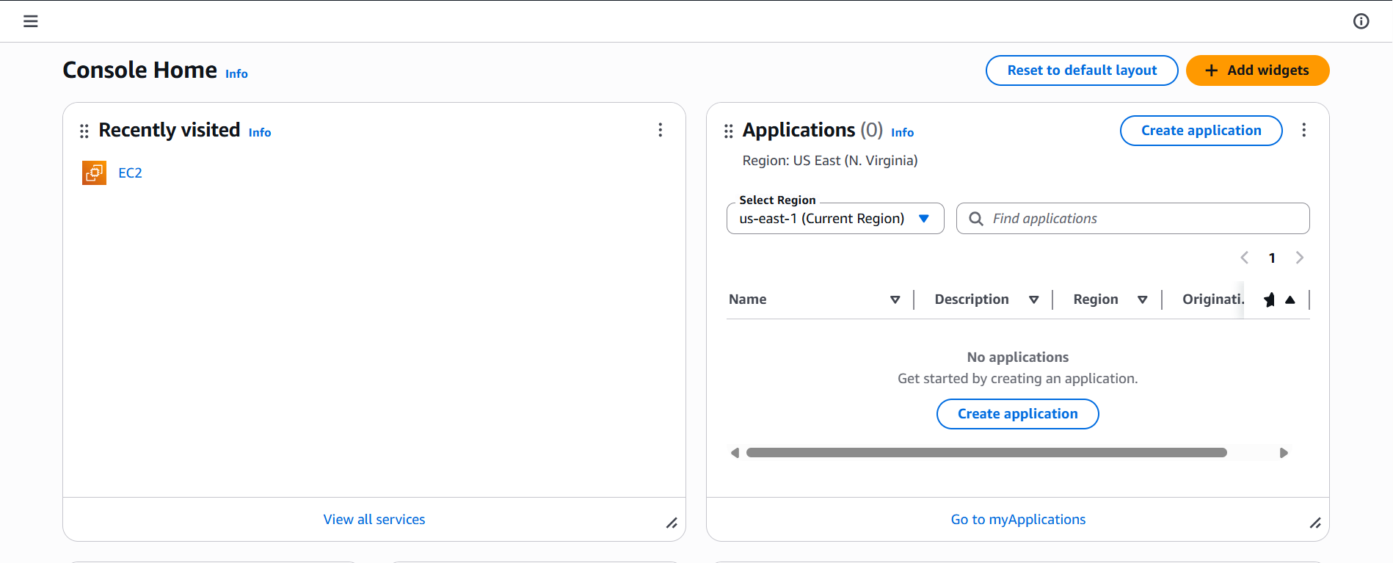

Click on launch instance

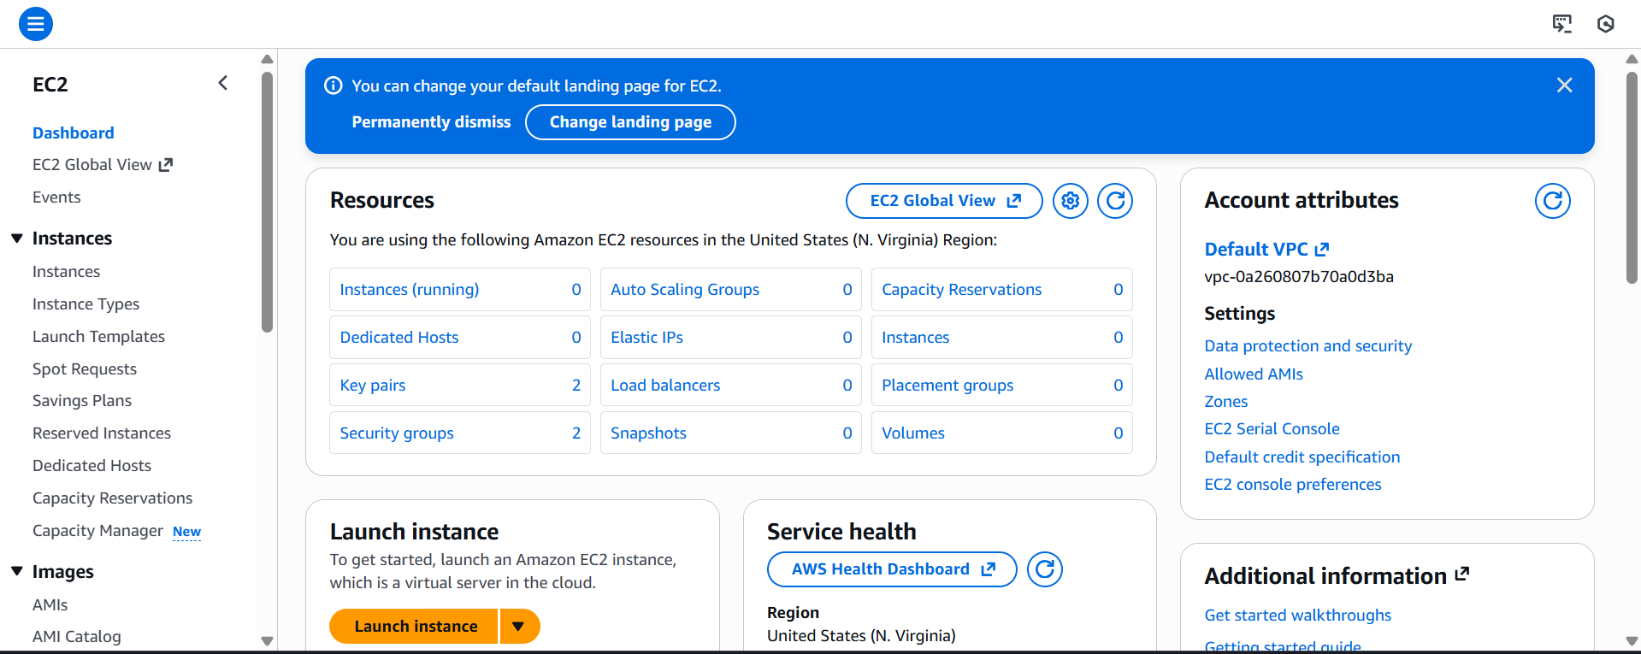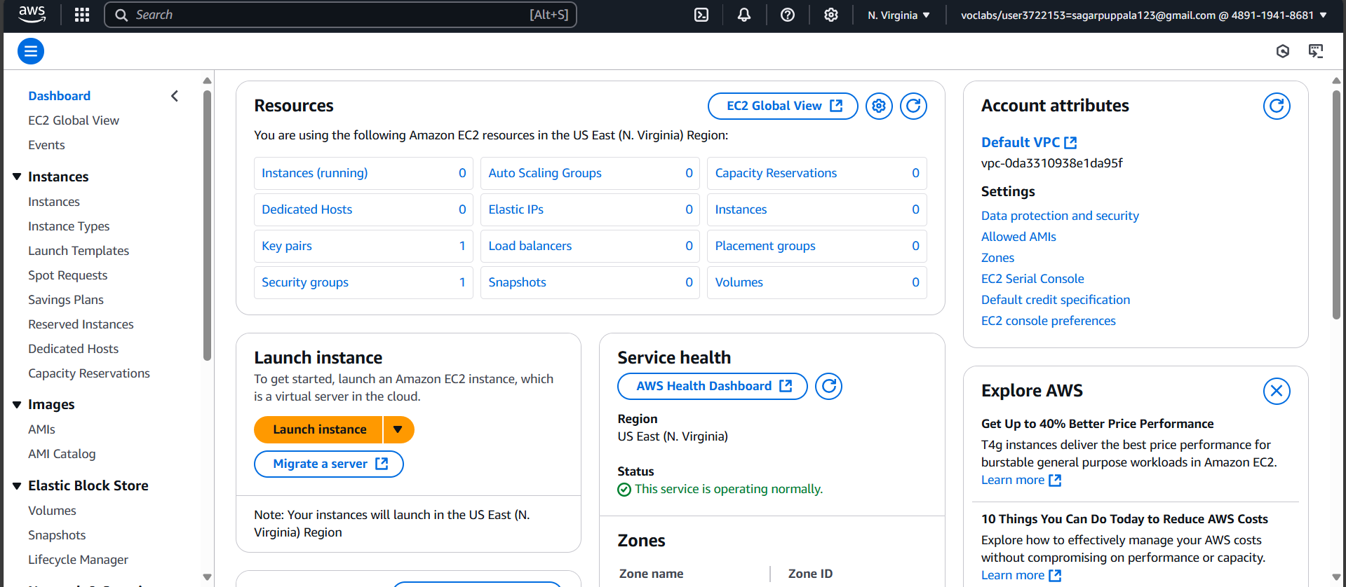

Give name

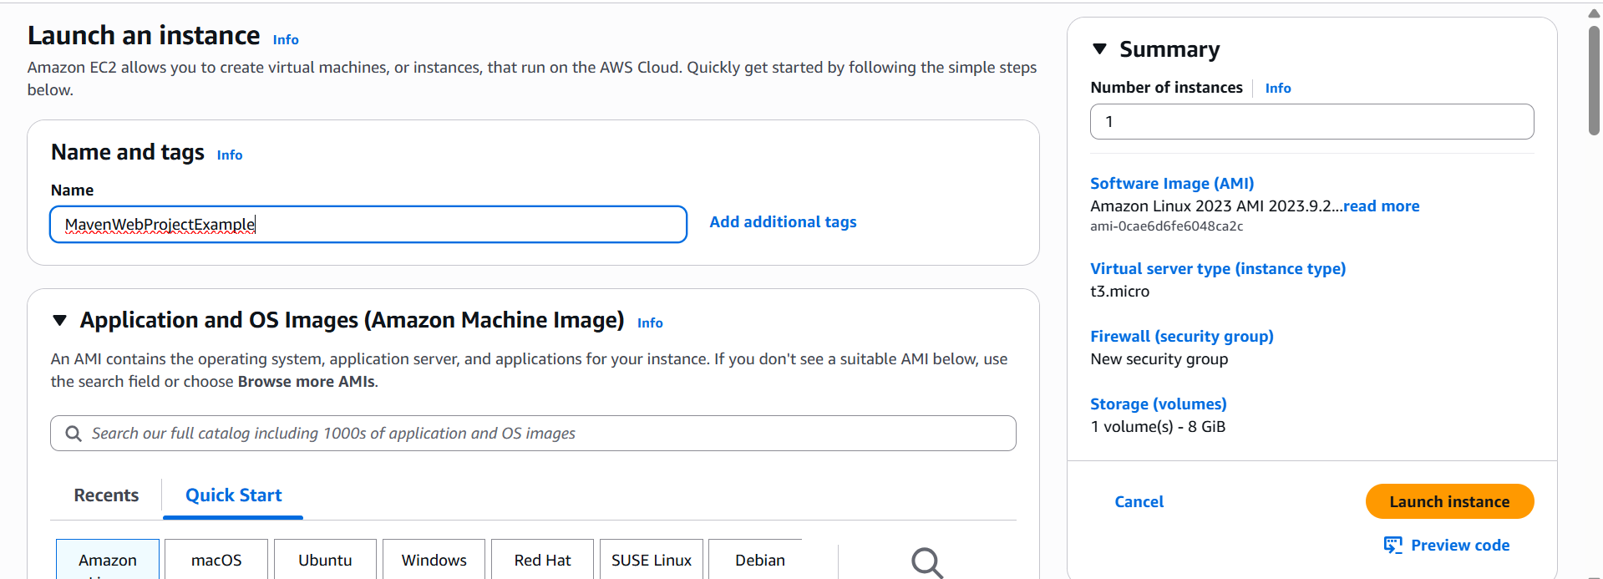

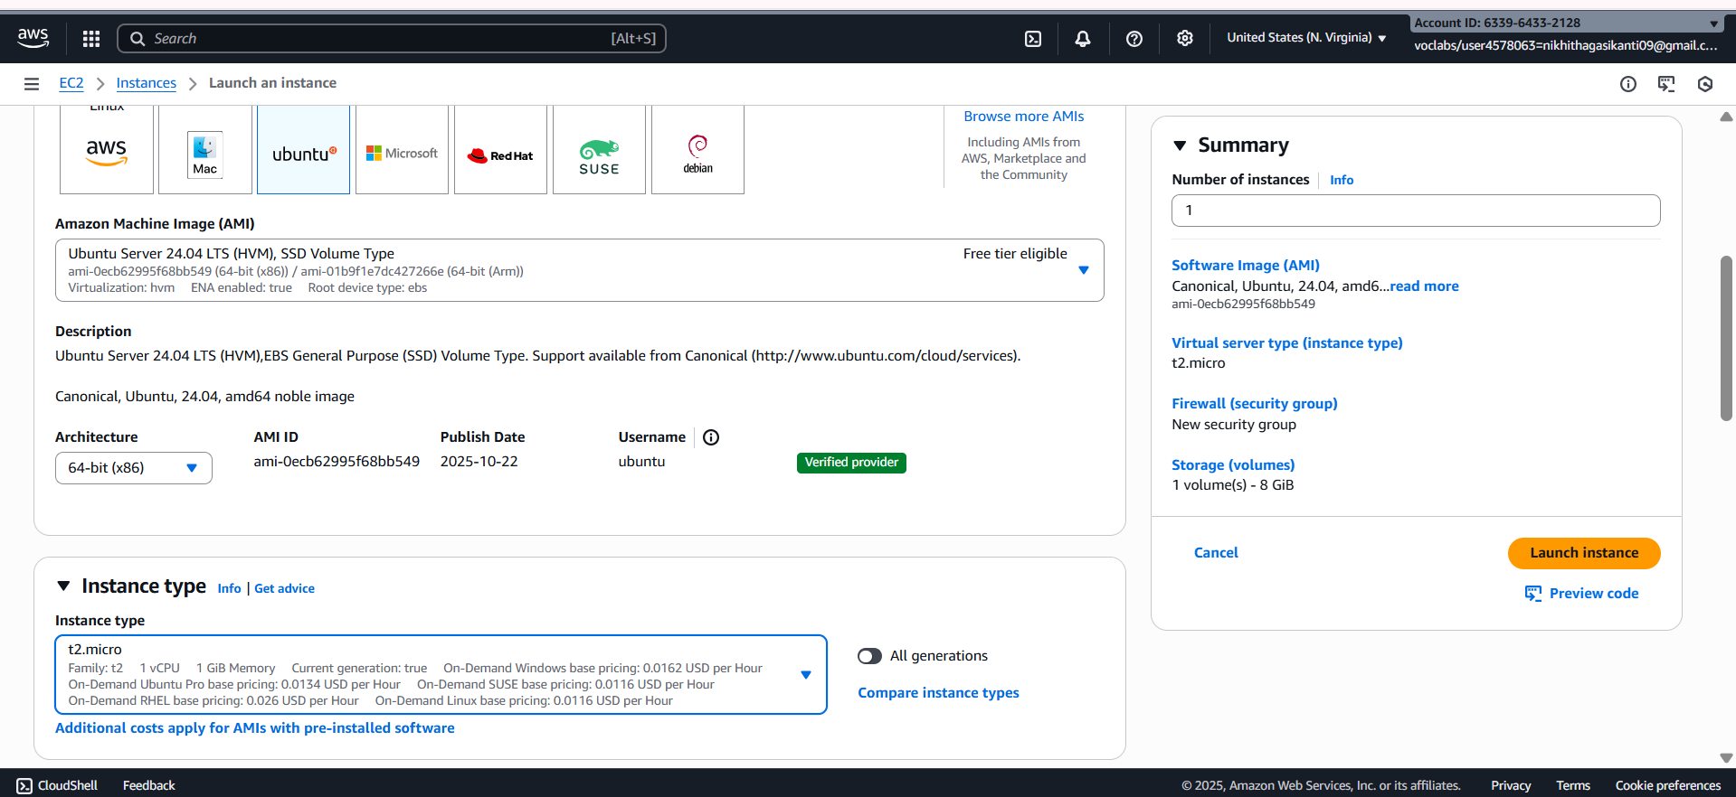

Create new key

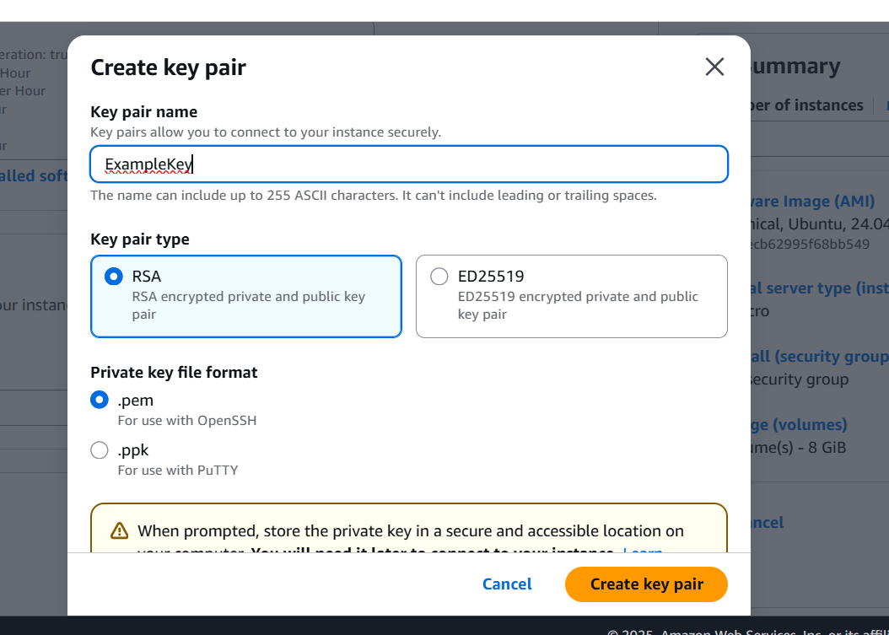

Check all the boxes under network and click on launch instance

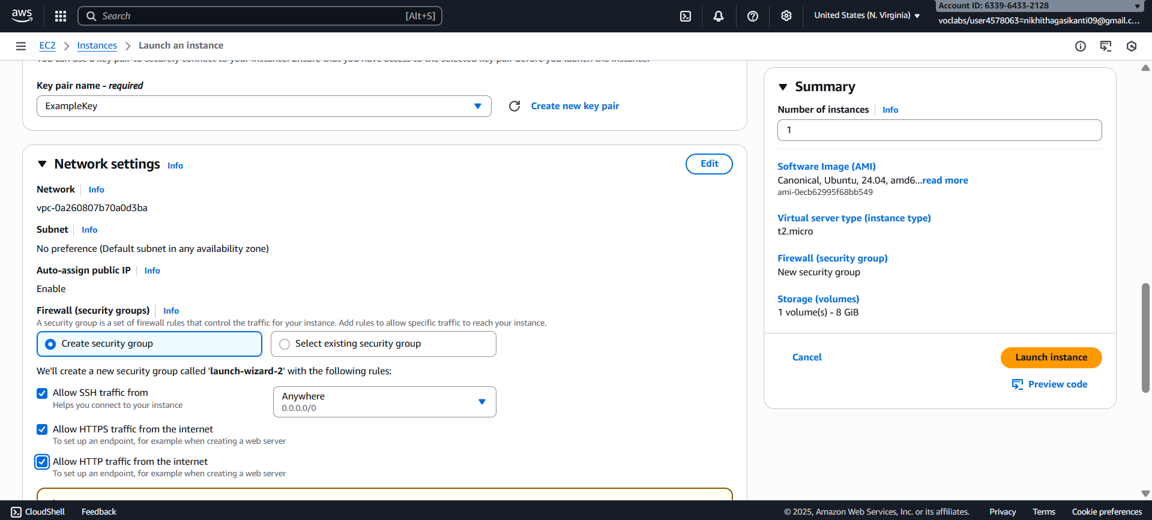

Click on instances

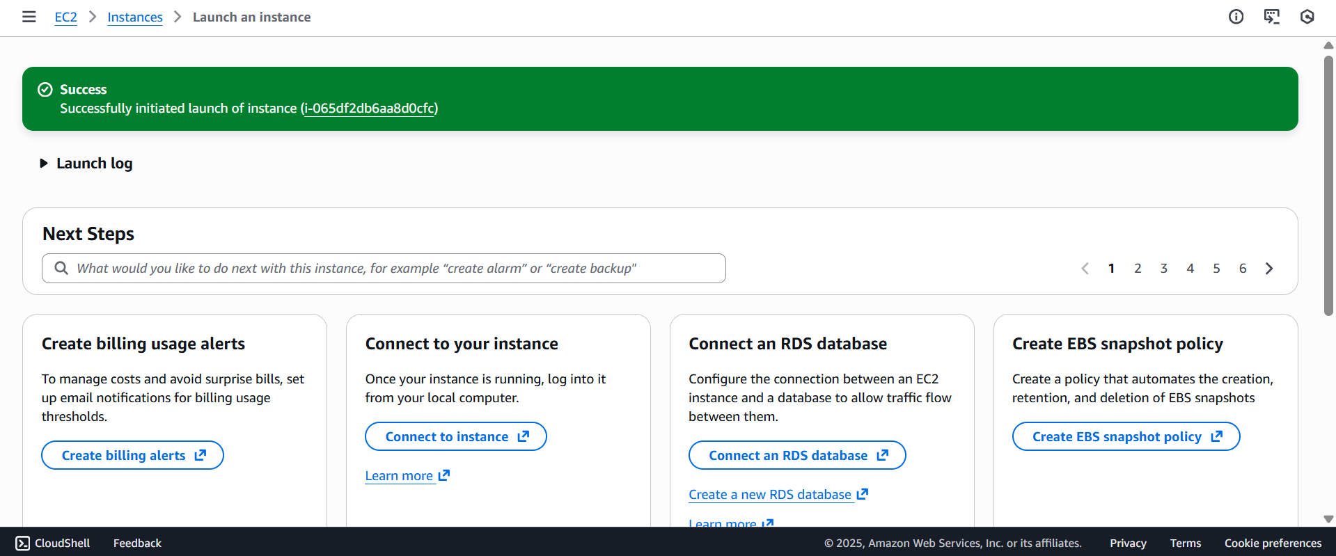

Wait until you get 2 tests passes

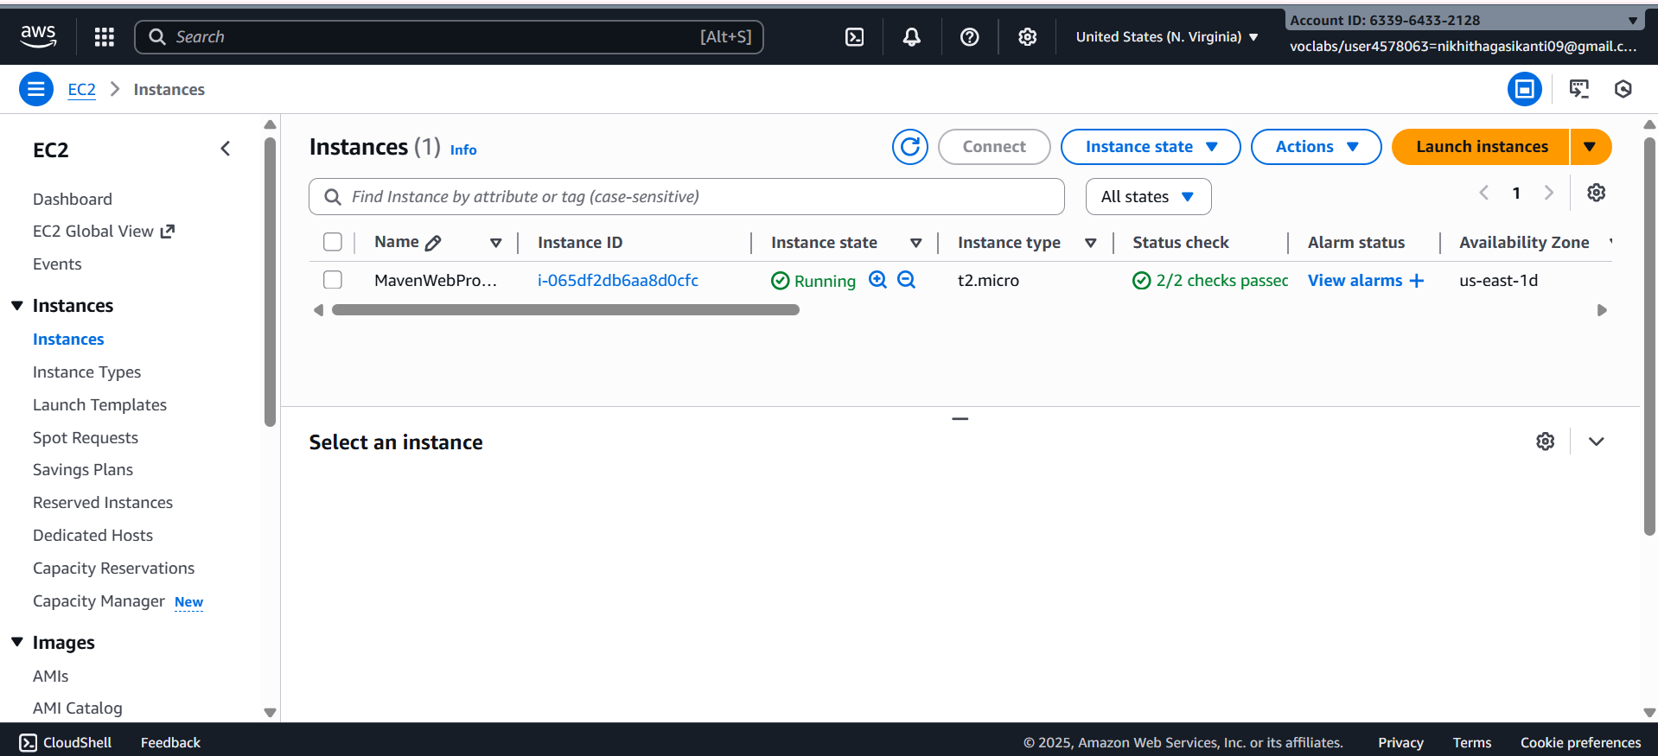

Click on connect after checking the box

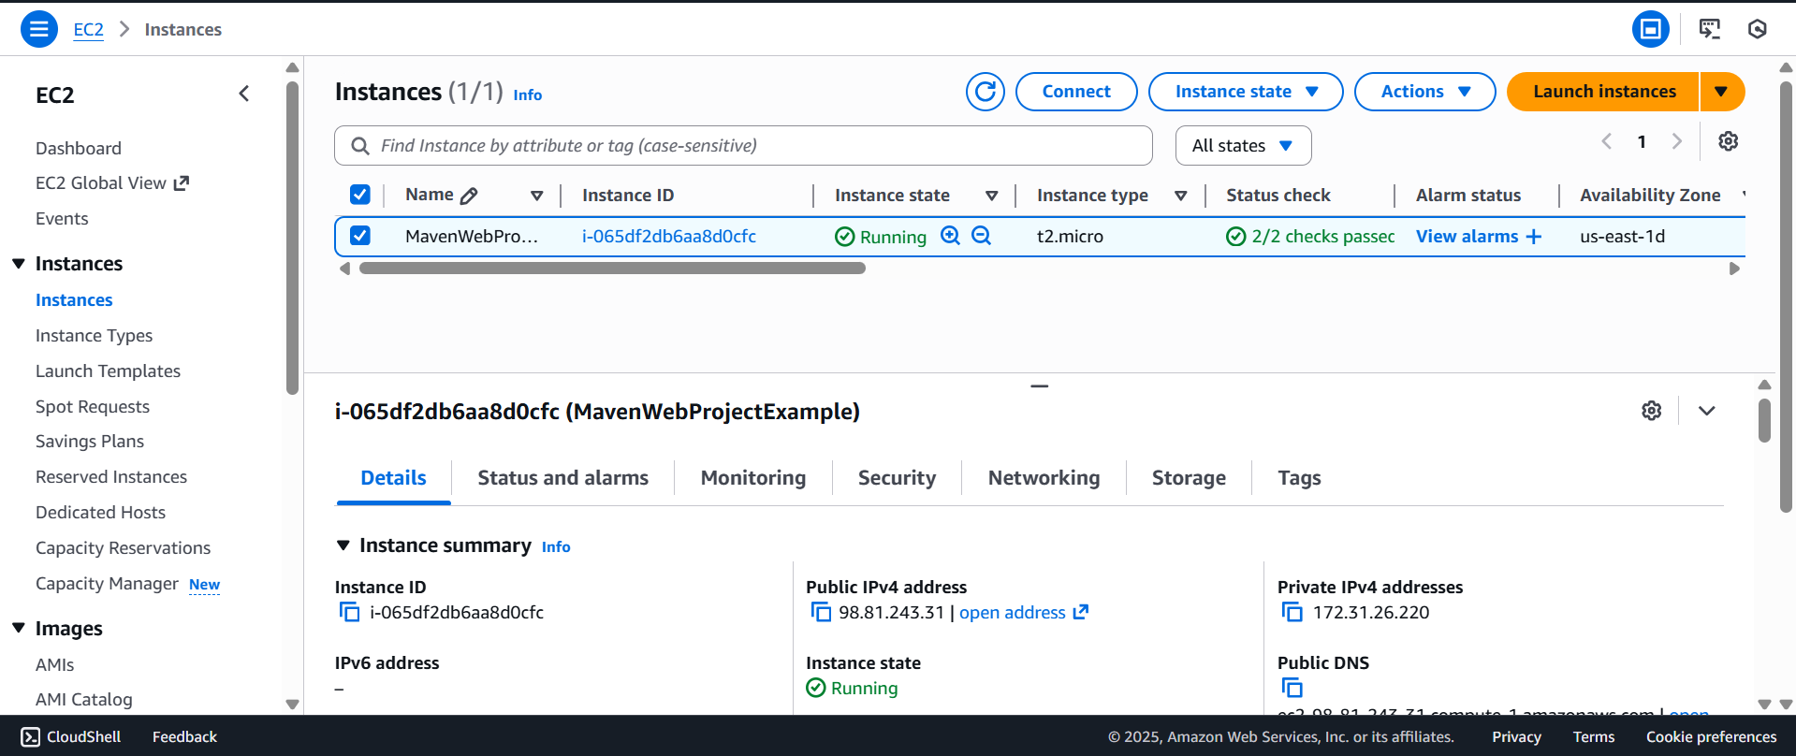

Copy ssh command

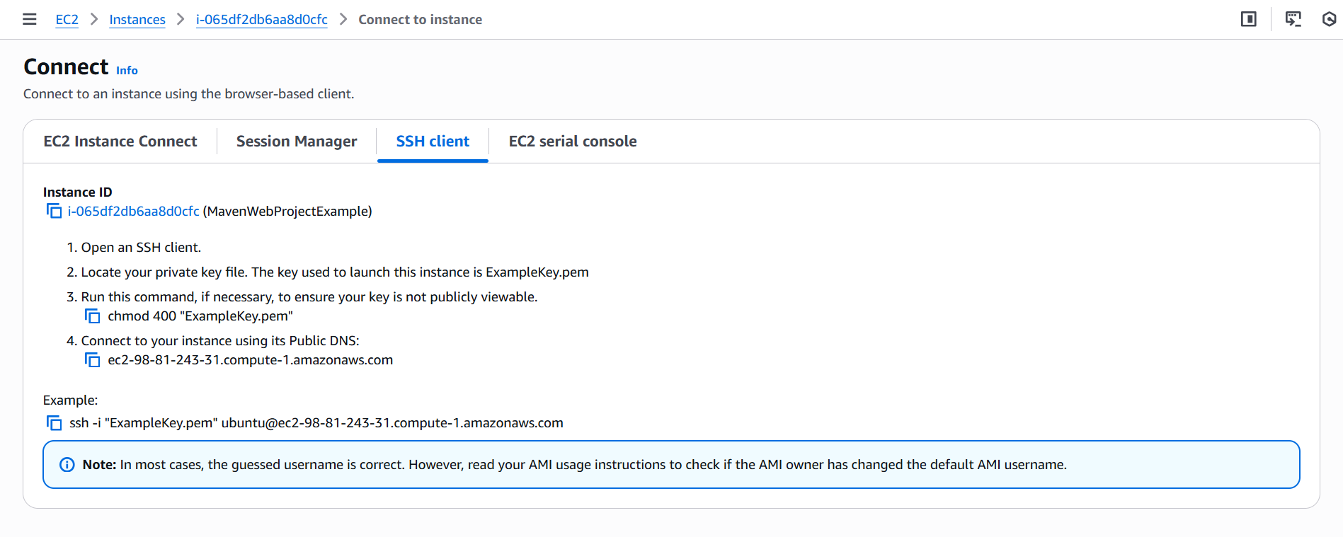

Open the terminal, Navigate to the path

Run the ssh command

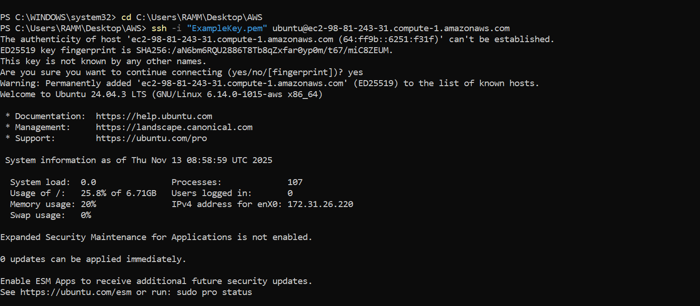

Run the following commands

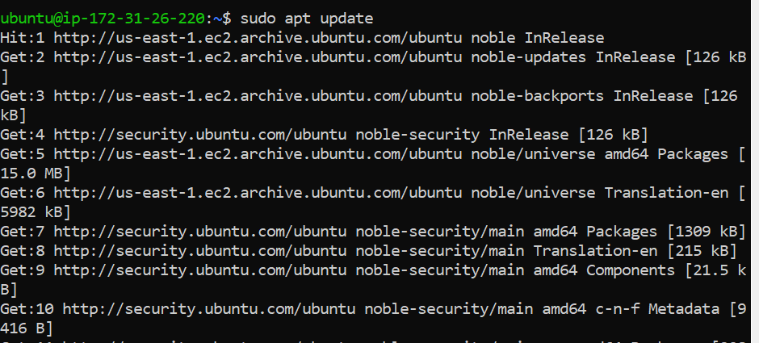

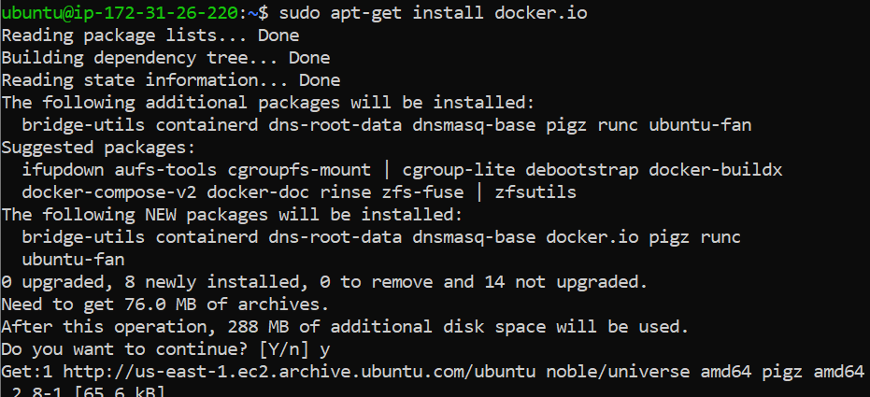

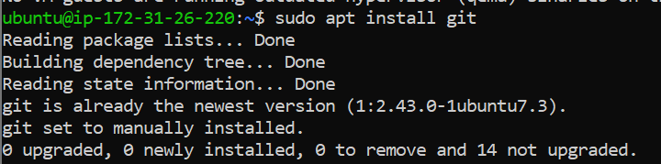

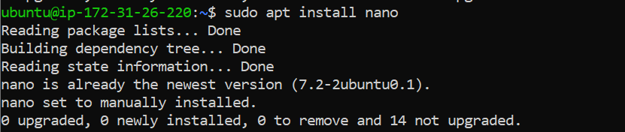

**Open MAVEN WEB PROJECT REPO in github and copy http link**

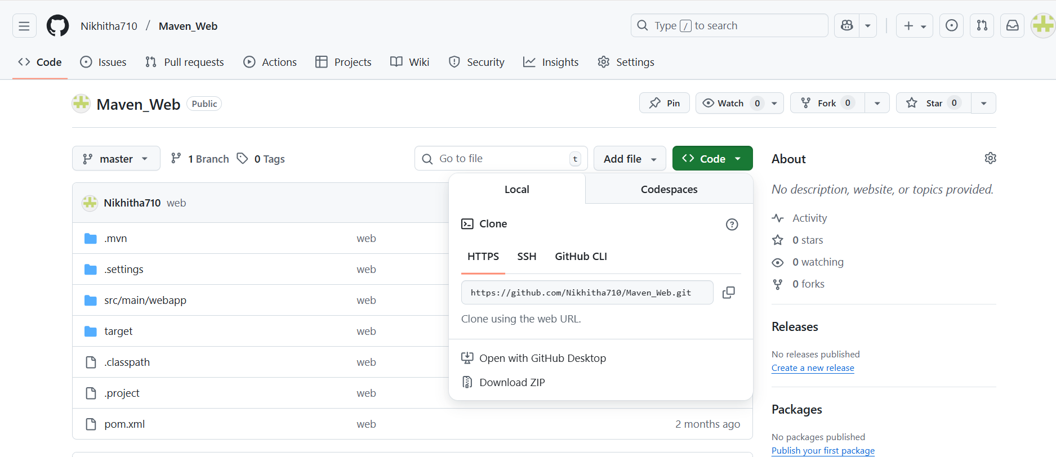

**Clone the repository**

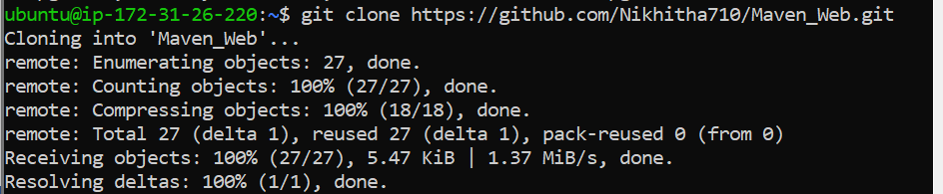

**If your repository is in main run following**

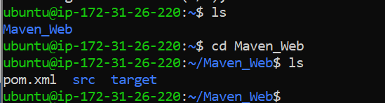

**If not goto your github repo**

**Click on settings**

**Under default branch section click on the icon shown and you’re your master branch as default and execute above commands**

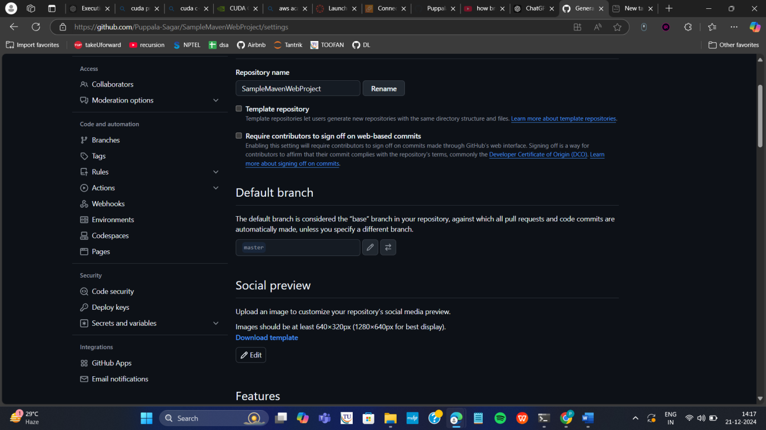





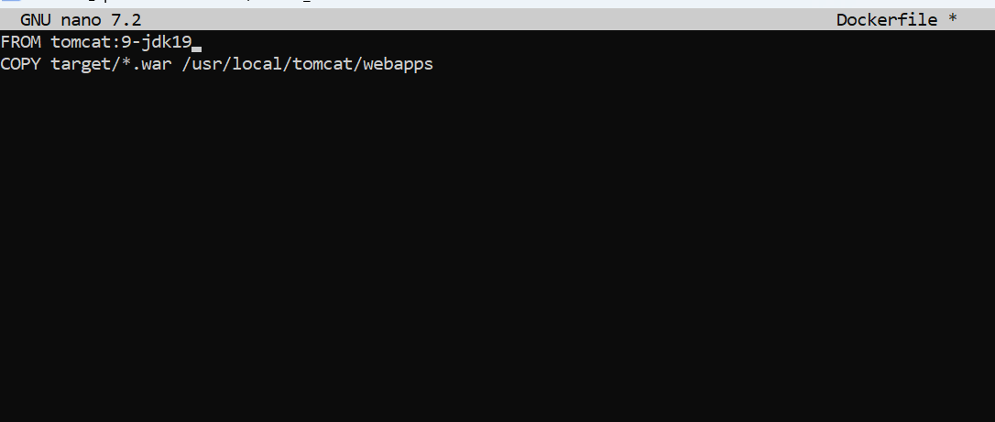

**Build docker image**

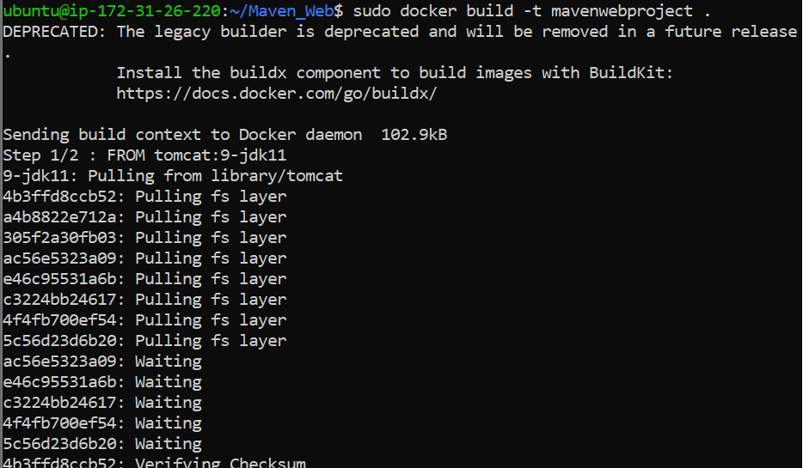

**Run the container**



**Copy public ipv4**

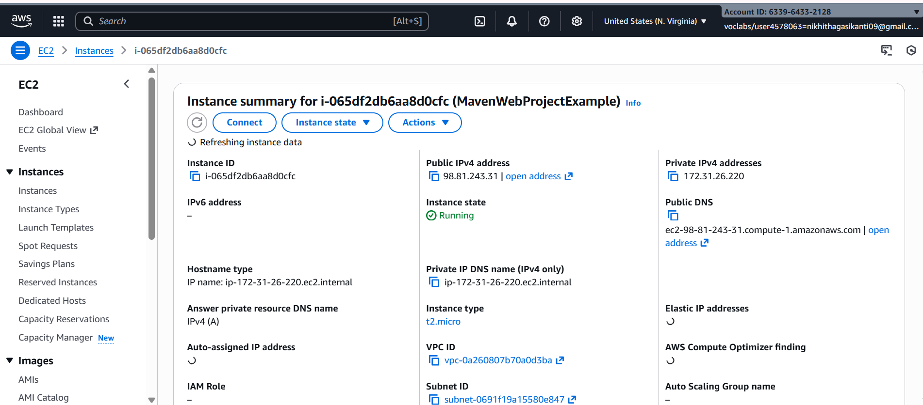

**Enter this url in browser and click enter**



**If your app is not running goto security and Click on security groups**

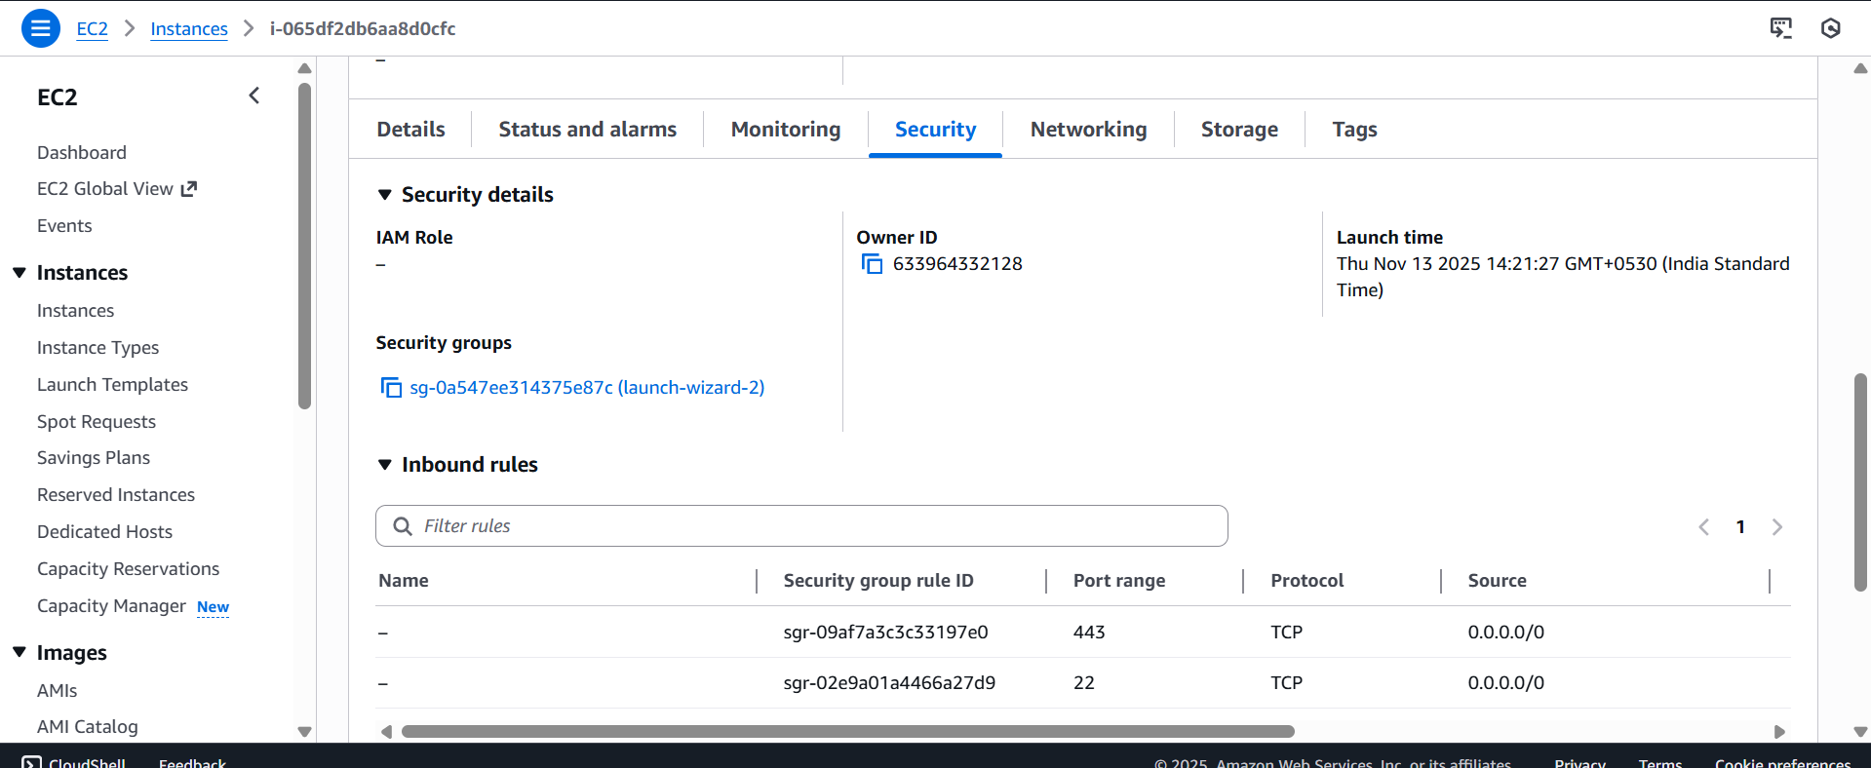

**Click on edit inbound rules**

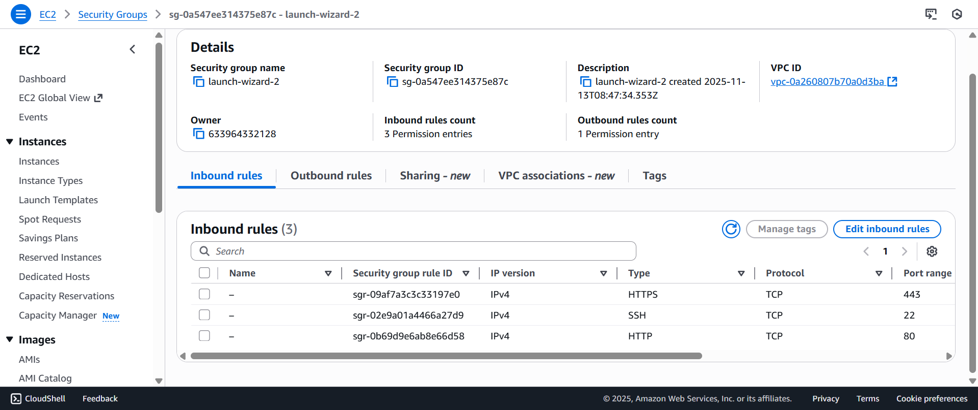

**Click on add rule give port as 9090 and 0.0.0.0/0 click on save**

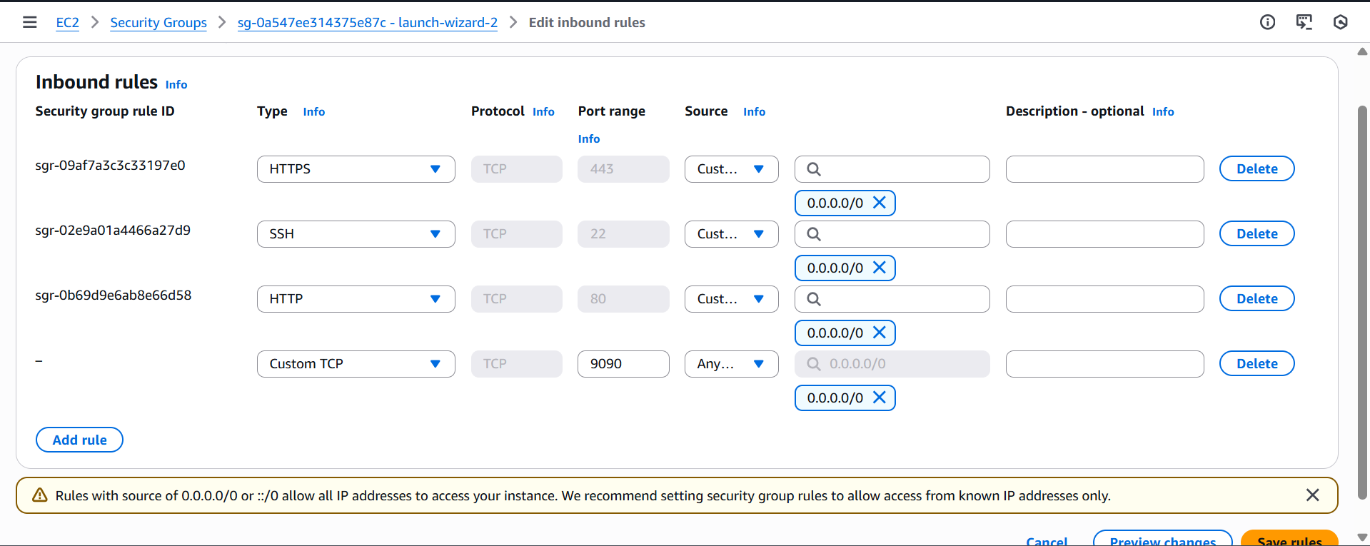

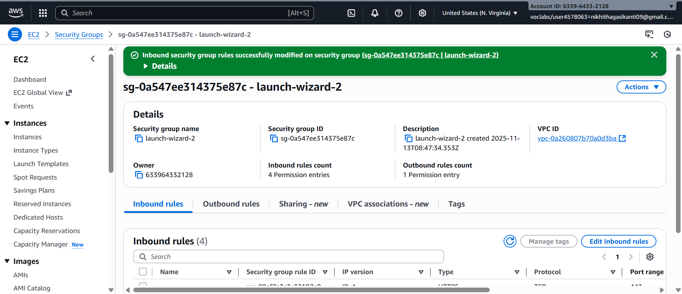

**And refresh the page to check whether the web page has loaded or not**

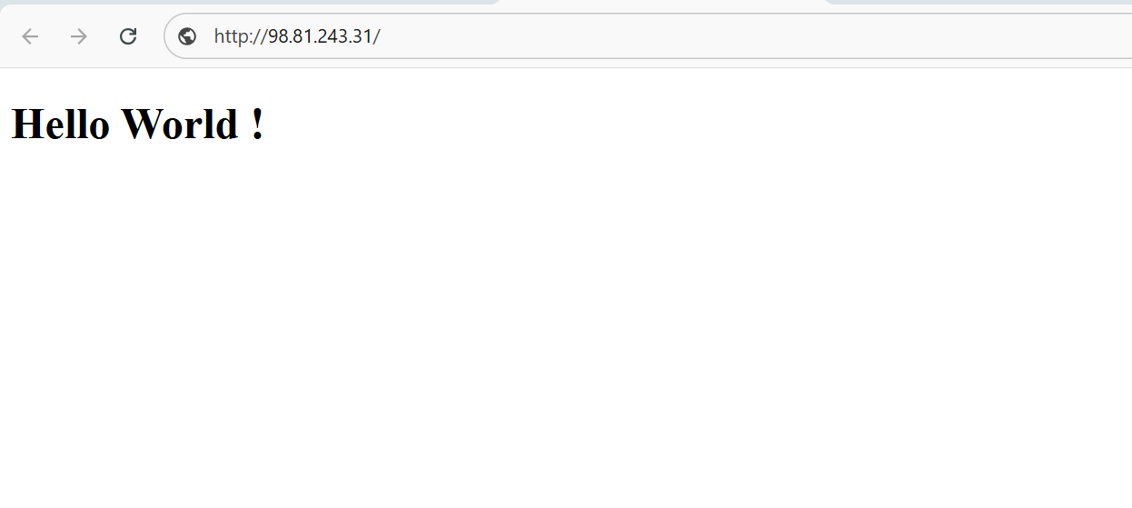

**If it is loaded you have successfully deployed you maven web project In your ec2 instance**

**Run the following commands to stop the container**

**Terminate your instance**

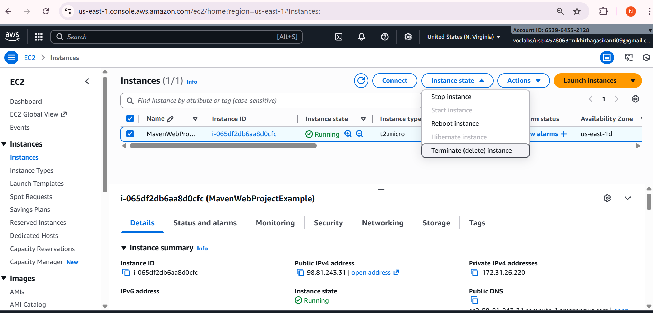

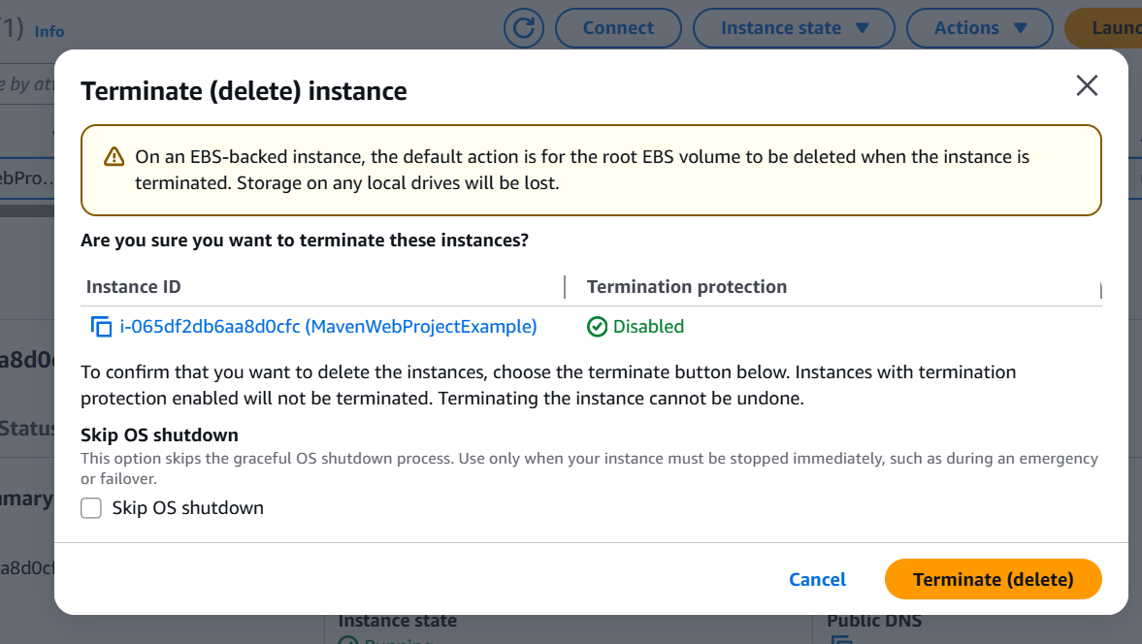

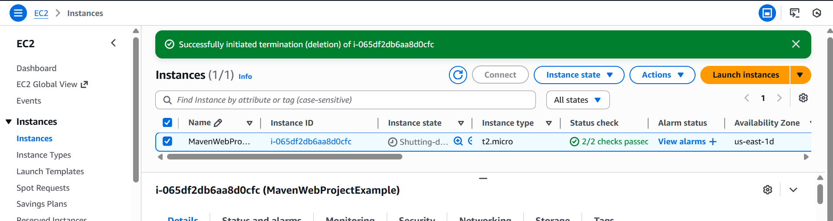

**End your lab**